Introduction

Few people are lucky enough not to experience financial pressures. In real life, many people face a lot of problems and challenges in saving money. (Ten Common Financial Challenges) People may experience different pressures, but they all want to be able to save enough money. Therefore, having a solution to help those people saving money is the primary purpose of this project.

The main functions in this app are tracking bills, setting budgets, pay functions, finance courses, discount coupons, and community sharing. These functions are all focusing on helping people save money clearly and efficiently.

The target audience for this app is a wide range of people from 18-50 because the app is designed to help all the people who need to save money, not a specific group of people. These people include but are not limited to college students with bad spending habits, people with no income, and adults with children and family to support.

In this semester, the Main() team has done two interaction circles. For the first interaction cycle, the team created a system concept based on the information and background research from the mind map, developed a medium fidelity prototype, and evaluated the prototype using Design Walkthrough, Think Aloud, and SUS. The team revised the existing system concept for the second iteration and improved the conceptual model according to further research and specific details of users' feedback from user testing. More features and interaction processes were added to the high fidelity prototype, and finally, the team conducted another evaluation on the final prototype using Heuristic evaluations, Pluralistic walkthrough, and TAM.

This report will include medium fidelity requirements, medium fidelity prototype, medium fidelity prototype evaluation, Revised Requirements, High Fidelity Prototype, High Fidelity Prototype Evaluation, Team Charter and Weekly Meeting Logs in the following section of the report. All the results from the evaluation process were included in the Appendix list.

Requirements

The following information in the system conceptual model is evolved according to the conceptual model in the mind map. This app aims to help people to save their money in a clear and efficient way.

System Concept

**One Sentence Problem Statement**

Design and develop a money-saving application that can be used on mobile devices(such as reminders/change mentality), which is used to help those people who want to save money. This app allows them to set a budget and helps them to maximize revenue by tracking their bills, providing coupons, suggestions and helpful courses.

**High Level Description of How the System Work**

This app aims to help those people who want to but cannot save enough money for various reasons. They might be students with less or even no income, adults who need to support children and pay off various loans(car, house), or people with bad spending habits. Therefore, this application provides four main features: tracking bills, setting a budget, providing finance courses, and providing coupons. Users can track their daily, weekly, monthly, or yearly bills by adding bills by themselves or bind their bank cards manually. They can set up their budget in order to limit their spending. This application can also provide several courses allowing users to choose according to their interests, and it also provides different types of coupons for users to reduce their consumption pressure.

**Interaction Paradigm**

This application will be considered as a mobile app that is available in both iOS and Android systems. Since the users are likely to spend money at any time, it would be more convenient for them to track their bills and know their lifting budget whenever they want. Also, notifying how much money they left is quite helpful immediately after the users spend money. Therefore a mobile device would be an excellent fit for this application.

**Interaction Mode**

The interaction mode for this application is giving instructions and custom functions . This application achieves “giving instruction” mode by providing search engines on the finance courses page, users giving instructions to the system to display related courses by typing something they are interested in into the search box. Sending messages or feedback to our system is another example of the giving instruction mode. “Custom functions” mode is achieved by providing several custom features that allows users to customize the feature and interface they want, these functions are included in the add bill page and setting page.

**Key interface metaphors**

This application includes several metaphor icons for our functionalities in order to match user’s mental models and help users working with our system more accessible. All of the main functions are represented by using metaphor icons. Bill element is selected for the checking bill function to notify the user that they can check their bill inside this function. Dollar element is selected for a budget function where people can check and set their budget. The wallet element is selected for the paying function, so users know they can pay by using it. A combination of people and paper elements are used for the finance function where users can learn finance courses they are interested in. coupons elements are selected for the discount function to notify the user that the function is related to coupons. Also, some metaphor icons are used in the add bill page. There are icons inside the category buttons, such as using book elements for study spending.

Design Guideline

This section provides a general design guideline for both UI and UX design of the application.

**Interface Design**

* Because this application is used on mobile phones, the interface must be simple and easy to operate.
* All the buttons or icons should be easy to notice and easy to click by hand.
* Because a user might use this app for an extended period, the color scheme should be bright, not make people feel uncomfortable, and the font size should be appropriate, so it will not make the user's eyes tired after long watching.
* Make sure the consistency of the interface design. In addition, the function must be clear, and the operation must be easy to save the user's time.

**User Privacy and Security**

When obtaining primary user and bank accounts information, please protect user information and prevent leakage. In this application, users need to set up a PIN (personal identification number), so when users want to pay, they need to enter their PIN, which is only known by themselves. This will improve the security to a great extent, and users can use the application more confidently.

**Custom Function**

Ensure that users can customize their own types of bills in the adding bill function, they can customize the name and the picture of the bill category so that they can create an adding bill page that they feel more comfortable with and more willing to use this feature and this application to save money.

**System Capabilities**

The most important job of this app is to help people save money. Therefore the bill and the budget situation are their most concern. In this app, a notification can remind users if they spend over budget and how much money they left from their budget, so users do not have to check their bill at any time by themselves, which can reduce their stress.

**Collect Opinions**

Having a good user experience will attract more users and improve the time they spend on our application. In order to achieve this goal better, make sure there is a way for the users to give their opinions, thoughts, and suggestions for this application. By using their feedback, the app will constantly improve their user experience.

System Requirements

|  |
| --- |
| **Interface operation**  Apps should have simple and clear operating instructions, easy to be noticed and operated by hand.  Rational: Users mainly use this application on their mobile phones, so function with simple and straightforward operation with fewer operating errors will bring users a better user experience.  Notice: “Frequent errors in operation makes me feel frustrated”- Suitable icons and font size make the operation easier and more comfortable. |
| **Notification function**  Notification about users’ bills, budget and finance courses.  Rational: Users may worry about whether they are over budget or need to attend class, and they need to check their app frequently without notice, so the notification function will tell them the information and help them reduce the stress, which will save them much time.  Notice: “Constantly checking my bills on this application makes me tired” - Notification messages reduce the number of time users spend reviewing their bills. |
| **Sharing function(Community)**  Share to Facebook/Wechat friends  Raional: Users may want to know how their friends are saving money, or they may want to share their tips with friends. That is where this function will be helpful for them.  Notice: “If I can share experience with my friend on this app, I will use this app more often ” - Sharing online will attract people to use this application. |
| **Security function**  Protecting users personal information especially the details of the bank account and their money.  Rational: Users will band their bank cards or other payment methods on this application, so they are concerned about their account and money security. A security function will make them trust more on this application.  Notice: “Sometimes I am worried about if my bank details are leaked when using money-saving apps” - A PIN(personal identification number) will be needed when someone wants to pay or check their personal information. In this way, users will feel at ease using this app. |
| **Bill function**  App users are allowed to add their spending and income in this app.  Budget function  App users are allowed to set their budget in this app.  Rational: In order to save money, users need to set up a budget, and the app needs to track their bills so users can see how much they spend and how much they left and make adjustments.  Notice: Bills have different categories, and users can choose to customize them. If the user adds a bank card, the app can automatically track every expense and entry in the card. |
| **Discount function**  App users can use the coupons to buy the products at a cheaper price.  Rational: Although users want to save money, it is unavoidable to buy the necessities of daily life. Therefore, it is very useful to help users reduce this part of the cost. This app provides several coupons and some coupons that are special for the student.  Notice: “I am glad to use coupons when I buy groceries. ” - Different coupons will be provided in the discount pages. |

Persona

Based on surveys and interviews, we have summarized the target users of three age groups, they have different occupations and consumption habits.

**First group: age from 18-24**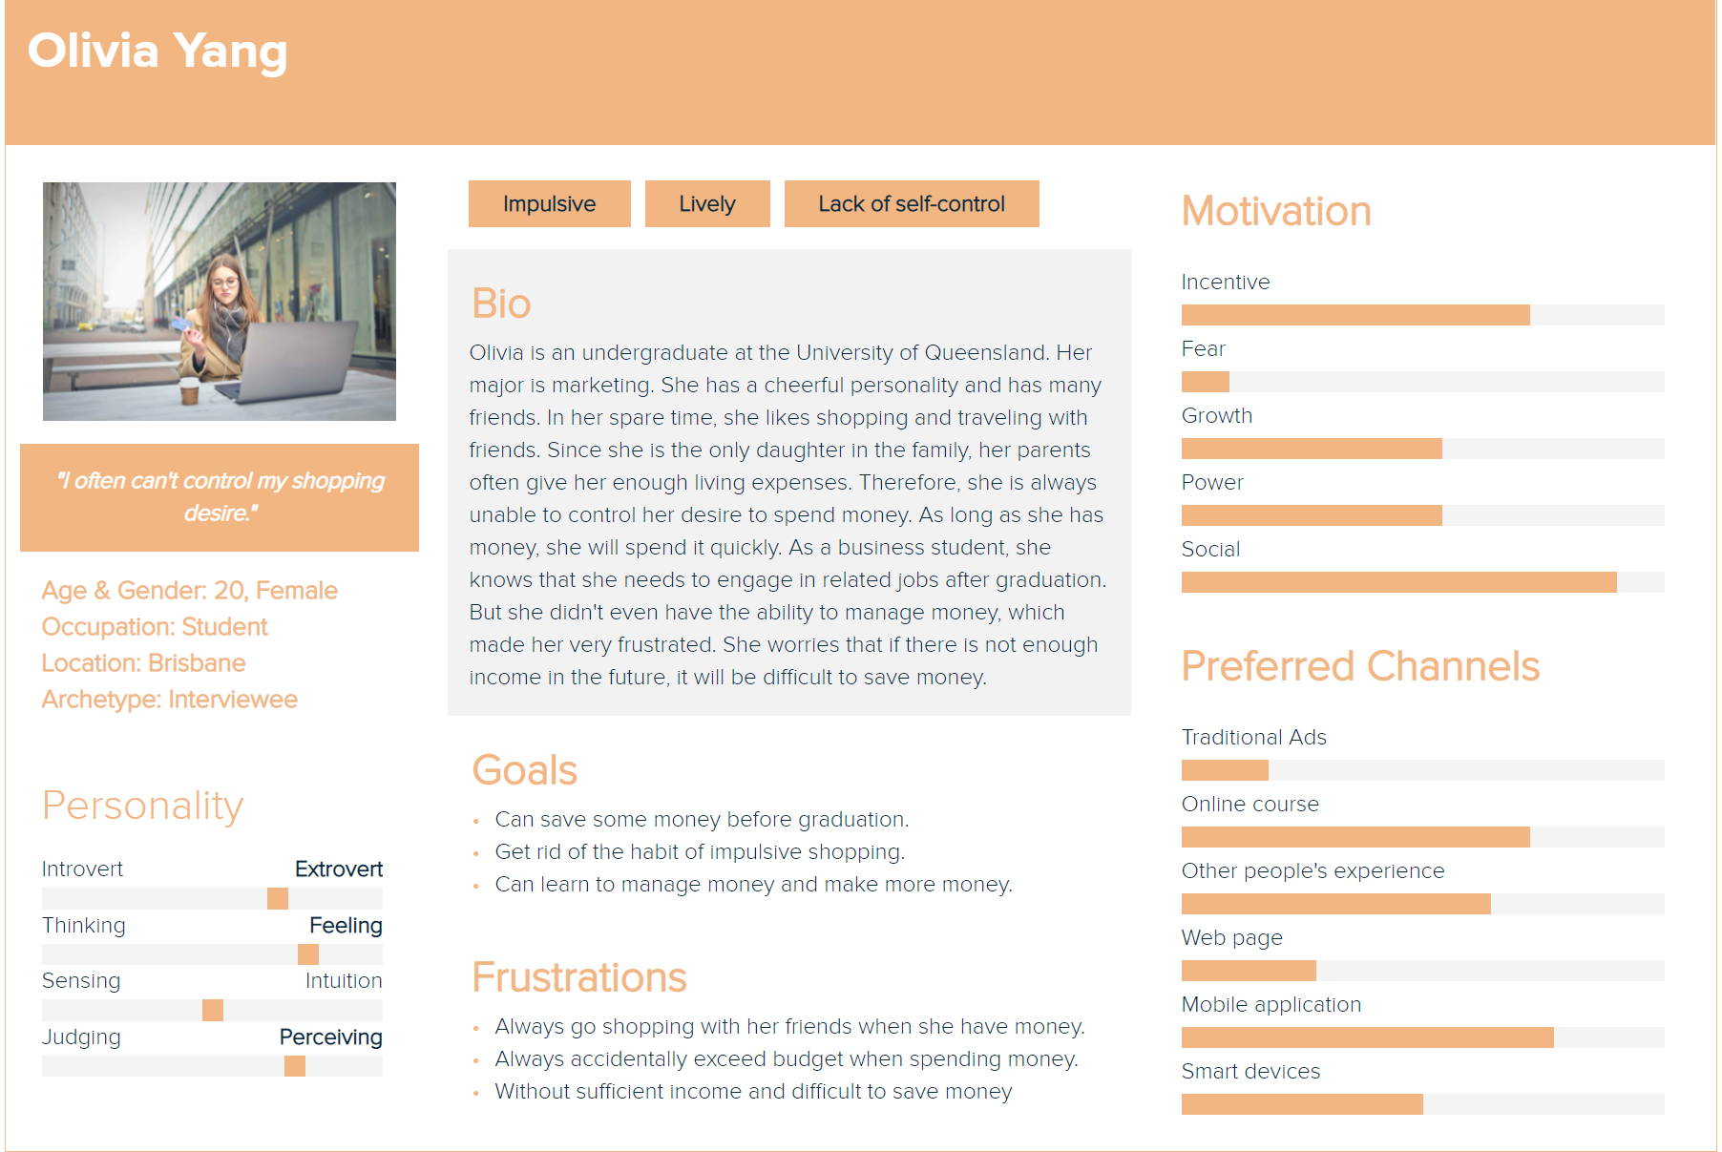

**Second group: age from 25-35**

**Third group: age from 36-50**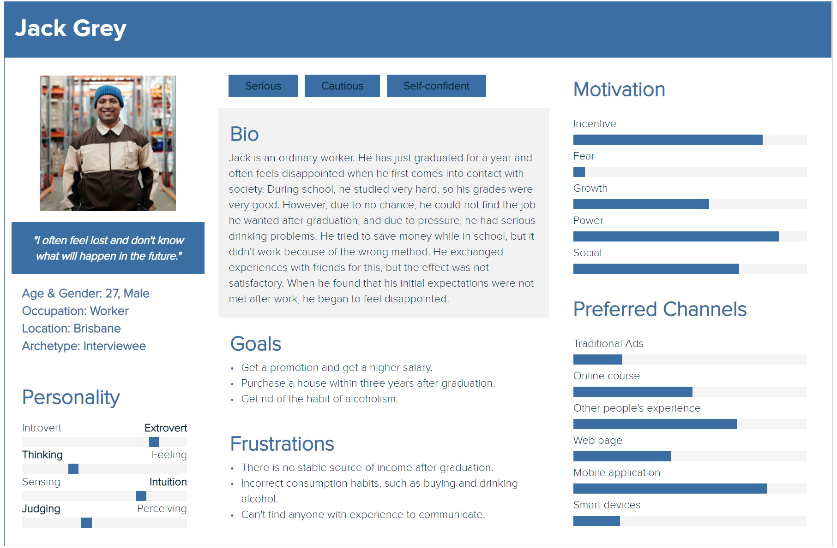

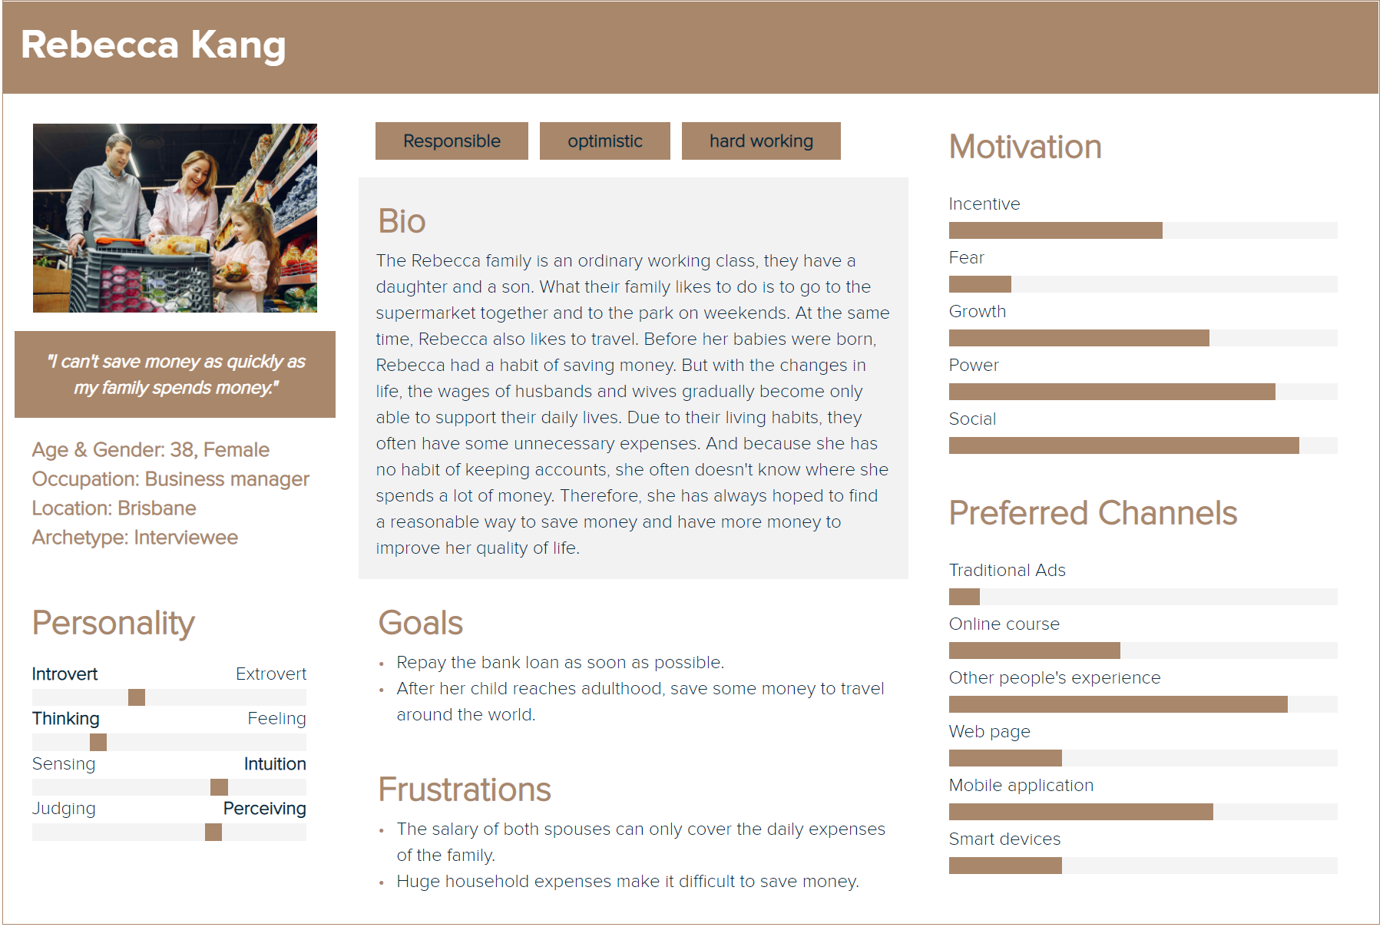

**Scenario** for each persona was made in **Appendix 2.4**

UX Goal

The content of this section is to discuss how to improve on the basis of low-fidelity prototypes to meet the conceptual design and system requirements expected by our target users. By analyzing the suggestions received from the interviewees, we created a ux table for the requirements of the medium fidelity prototype. The following list includes our ux goals and system requirements.

|  |  |  |  |
| --- | --- | --- | --- |
| **Source** | **UX Goal** | **Measures** | **Requirements** |
| Interview Participant 01  “I am trying to find out if I can log in with my google account and I feel it is a waste of time to log in again whenever I go back to this app” | I want to have multiple ways to log in and want the app to remember my account, so I do not need to log in every time. | Time measurements,  Survey questions:   1. “I find it troublesome to log in every time” 2. “I want to log in use my google account” | * Multiple ways to login(google, facebook) * Remember me button |
| Interview Participant 02  “When I look at this app, I always try to find the icon buttons but find it is hard to notice them….I find the primary color familiar because it clashes with the app in the market. ” | I want to see the icon buttons clearly and be able to change the color of the background. | Survey questions:   1. “The main color style(yellow and white) can increase my interest in using this app.” 2. “I think these pages are clear to understand how to use this app without tutorials.”   Customer interviews | * Button to change the background color of the app(according to the user’s preference) * Icons with prominent color(different with background color) |
| Interview Participant 03  “There should be a protection on bank and personal detail when user leave from their phone” | I want a PIN number when someone wants to check my personal and bank information in this app. | Survey questions:   1. “I am not sure if my personal information will be seen by other people.” 2. “I want my personal information to be protected.”   Customer interviews | * PIN (personal identification number) |
| Interview Participant 04  “I do not know the price and quality of the lecture. It will be nice if I can see it without burden.” | I want an affordable lecture with a suitable price and its duration should be short. | Survey questions:   1. “I would like to know the evaluation of the course before subscribing to it.” 2. “I accept the course recommendation emails sent from the app.”   Customer interviews | * Implementing a sign-in system. Users can use points to exchange lectures. * Dividing the lecture into several parts. * Flexible email recommendation function |
| Interview Participant 05  “I am thinking what should I do if I encounter problems during use or have questions about the functionality of your application? I may not be able to solve these problems alone. Is there any question and answer service that can help me?” | I want customer service and a way to report bugs. | Survey questions:  “What kind of support do you need when you have problems?”  Customer interviews | * Implementing customer service. |
| Interview Participant 06  “There should be a notice function to noticed user that how many budget they left everyday and also have a monthly and annual expenditure summary ” | I want a notice function to remind me of my budget and a sum up to tell me the summary of my spending monthly and yearly. | Survey questions:   1. “I probably would forget to use this app without noticing how many budgets I had left.” 2. “Setting up a budget function can help me cut down on unnecessary spending..”   Customer interviews | * Making a notice function on the first page and after payment. * Making a monthly and yearly sum in “my budget“ function. |
| Interview Participant 07  “I am a student so to me i prefer have a student discount in the discount page to show which discounts are specific to student” | I want a student discount on the discount page. | Survey questions   1. “What do you think about discount pages?.”   Customer interviews | * Improve discount page. * Set up a student discount area on the discount page. |
| Interview Participant 08  “ Regarding the main function, I don't understand why the bank card function is placed on the homepage. I only add a bank card when I enter the app for the first time. This is not a feature that I need to check frequently. On the contrary, if the program can have a function to facilitate my payment or collection, and it can be reflected in the bill in time, then it will be convenient for me.“ | I want the functions of the homepage to be the functions I use frequently, and these functions should be convenient for me to use. | Survey questions:   1. Do you think the existing accounting functions are attractive to you？ Is it easy to use？   Customer interviews | * Put the function of adding a bank card on the personal information page. * Convenient payment and collection methods (homepage) eg: PayPal; Scan code etc. |
| Interview Participant 09  “Because sometimes I may forget to record the cost of a day because I am too busy with work or study, so when I see that the date selection of the accounting function can only be today, I think this will make my billing time inaccurate. Moreover, I always struggle when choosing a category, because I only remember that all I buy may be food.” | I want flexible accounting functions and unified classification options to facilitate me to fill in the missing bills and make my bill classification easy to remember. | Survey questions:   1. “I think the existing accounting classification function can give me a better user experience.“   Customer interviews | * Add the option of selecting date in the accounting function. * Unified and related expenditure/income classification. |
| Interview Participant 10  “When I browse the community, I always want to check the money-saving posts posted by my friends first. This allows me to compare my money-saving achievements with them. I think this can make me more interested.” | I want to communicate with my friends, discuss our money-saving experiences and methods, and share them with each other. | Survey questions:   1. Do you think the communication function can help you use our app?   Customer interviews | * Relevant function of Invite friends. * View posts from friends in the community. |

Medium-Fidelity Prototype

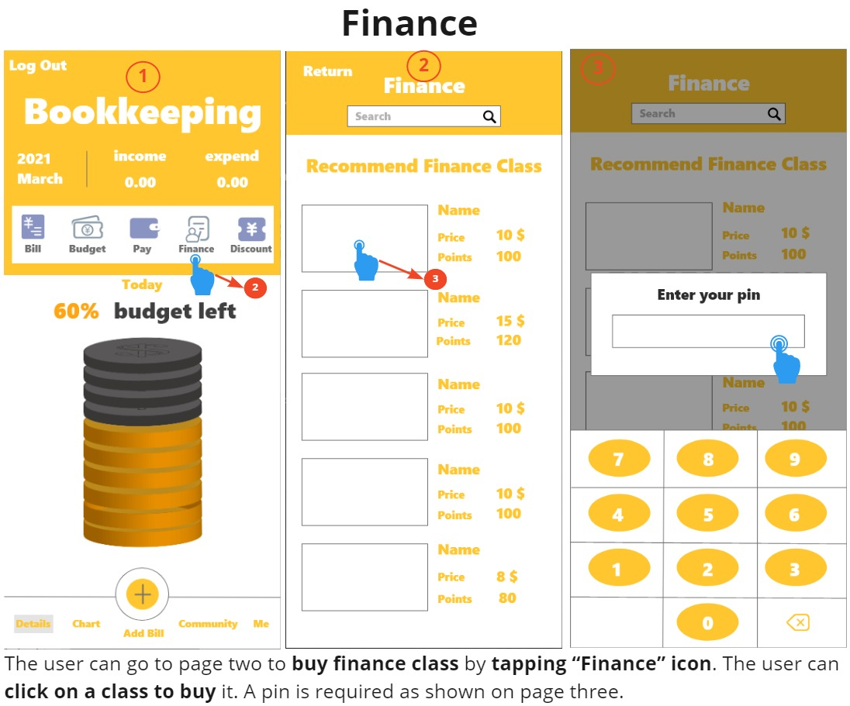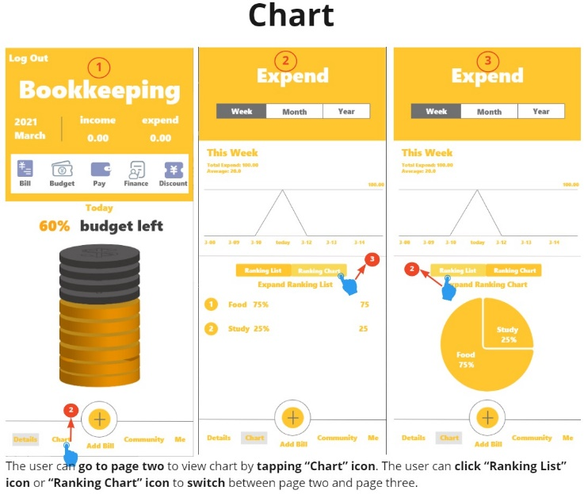

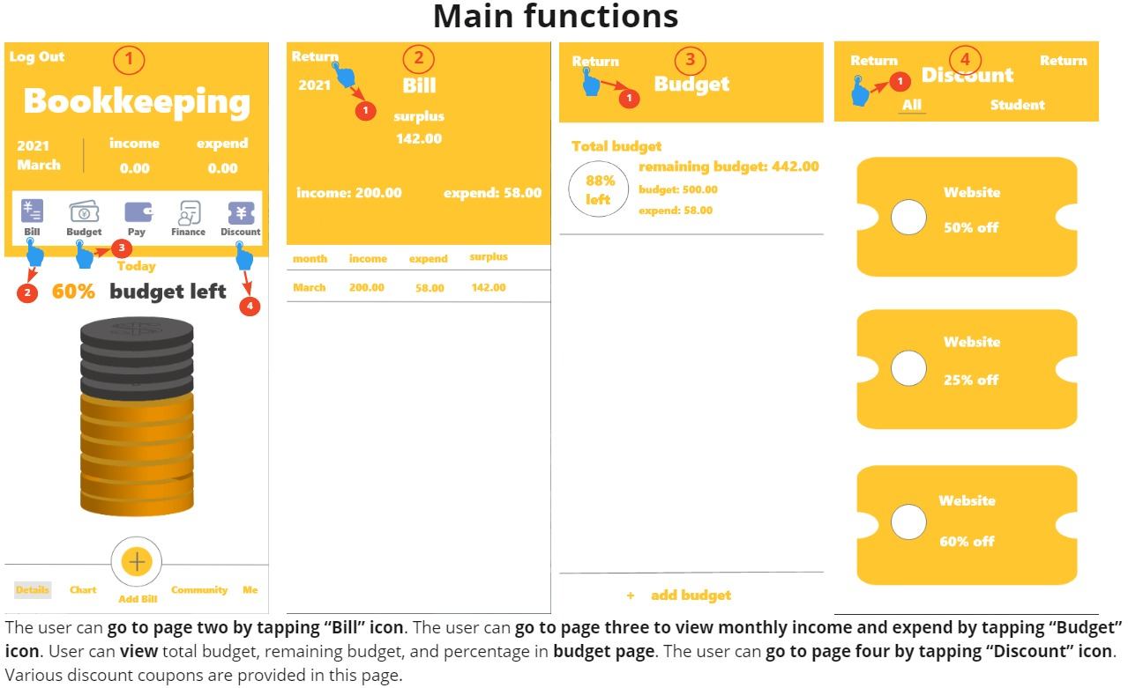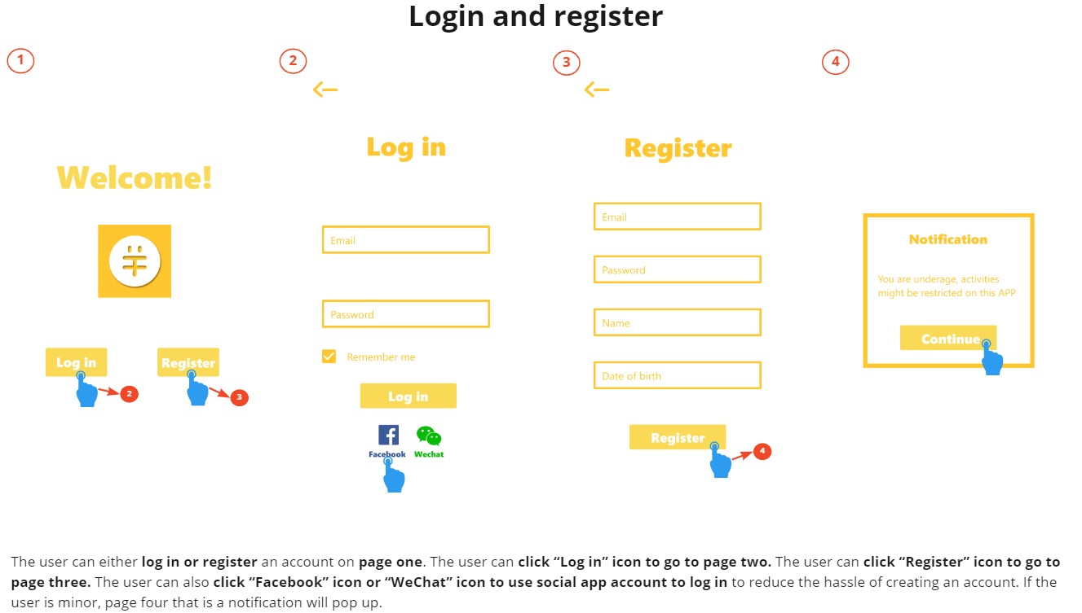

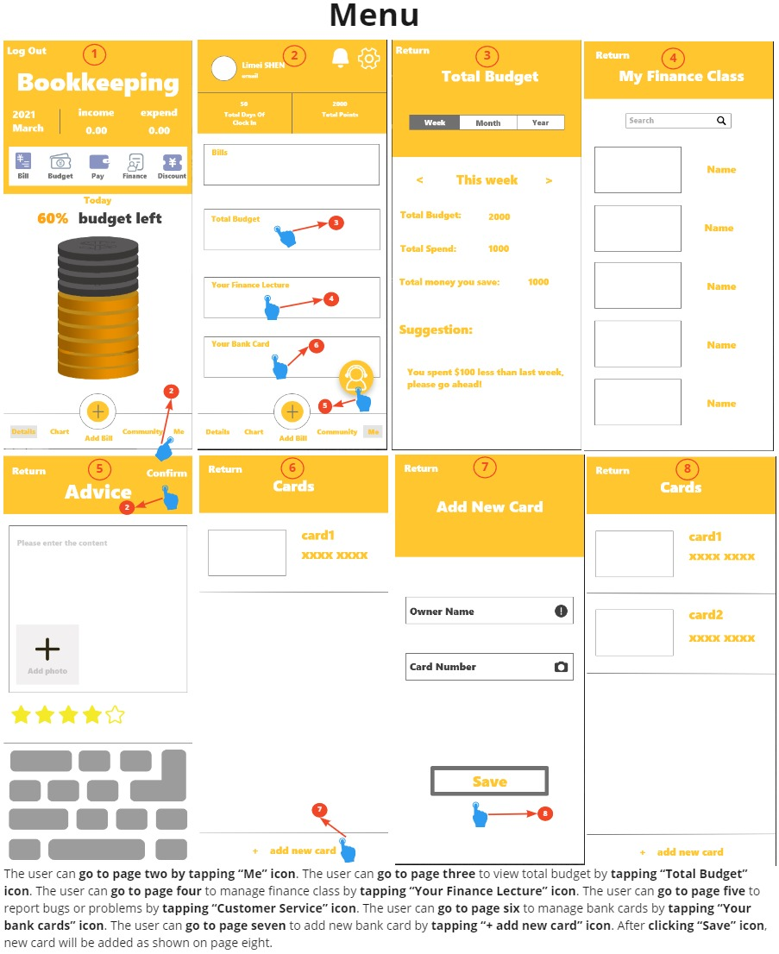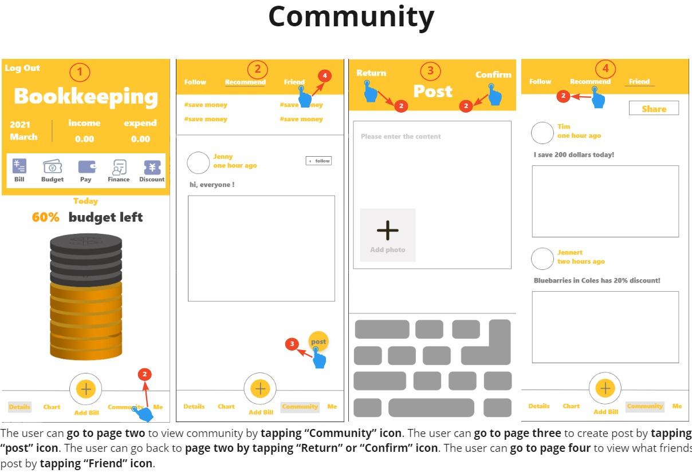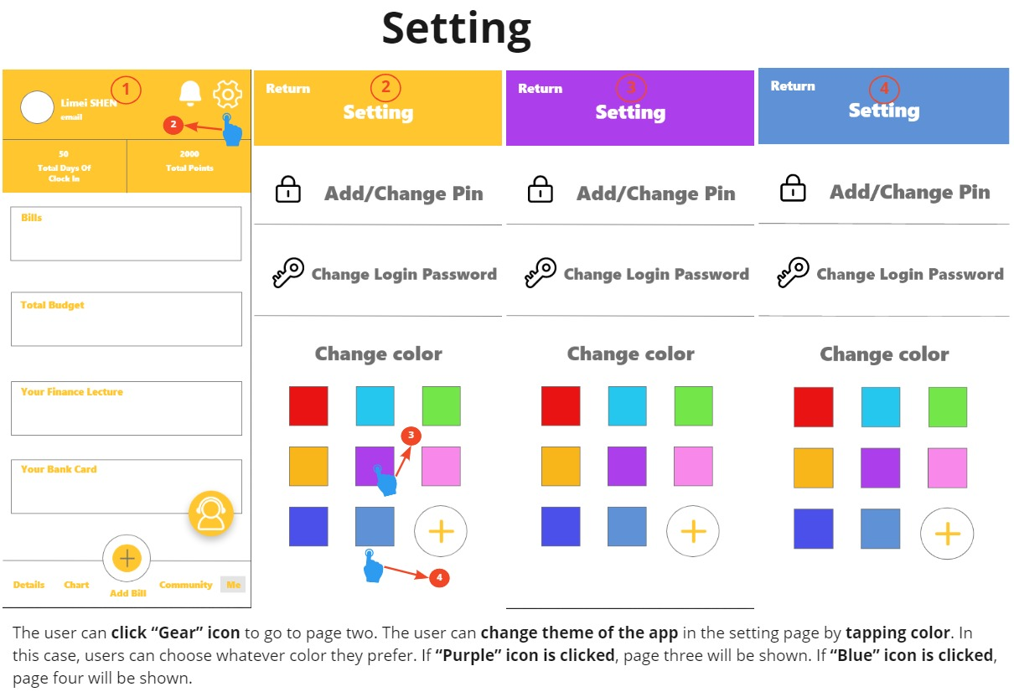

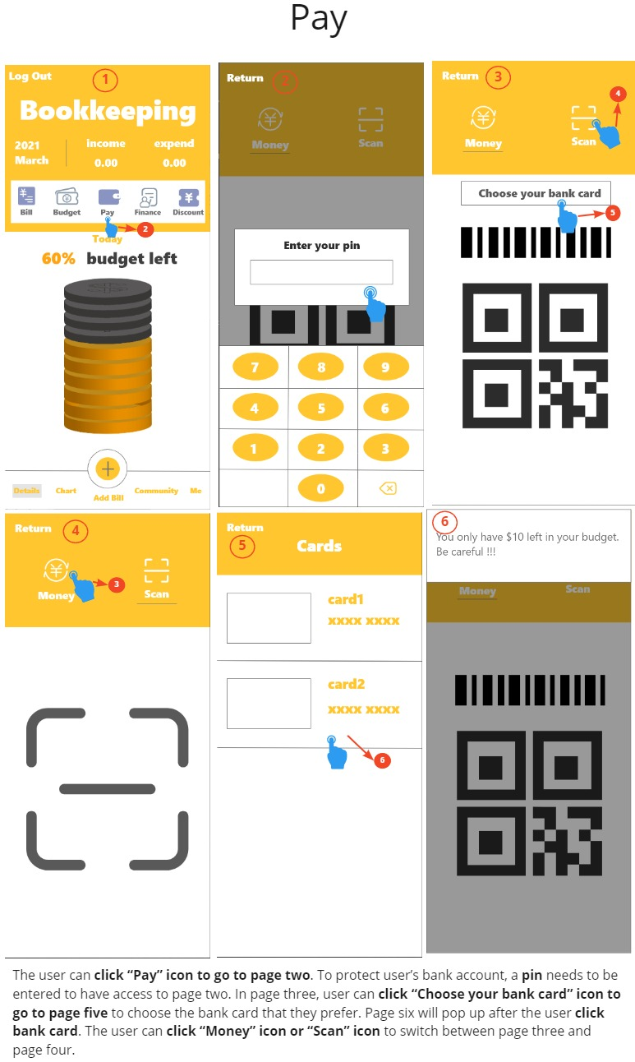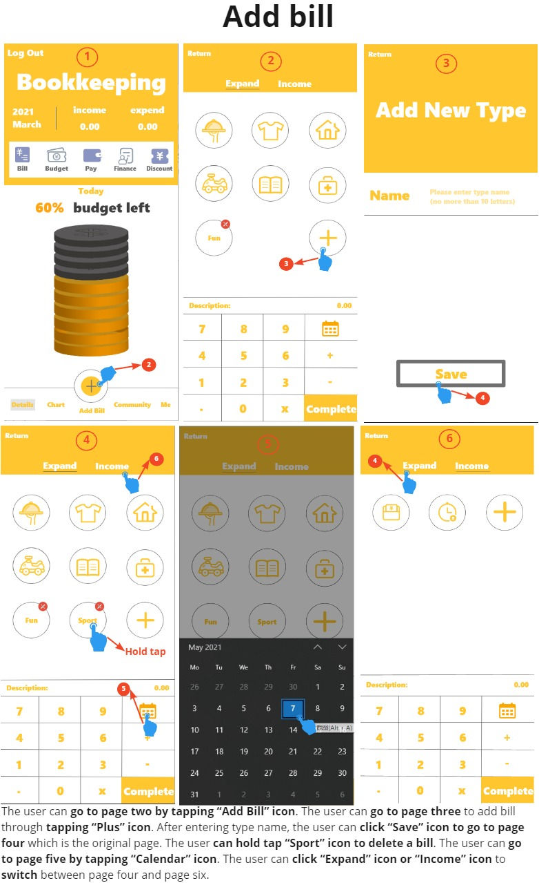

Medium-Fidelity Prototype Evaluation

Medium Fidelity Prototyping is “the first realistic physical presentation stage in product development, which allows evaluation of user interaction with a physical and functioning product.”(Aree, n.d.). We hope users could understand the function and user interface, establish some user experience during the test and give us feedback.

In this evaluation, we invited 13 testers to test.

**The methods used to conduct this evaluation includes:**

• Design Walkingthrough

• Thinking Aloud

• System Usability Scale (SUS)

Detailed Evaluation Methods 2

**Design Walkthrough**

**Background of Design Walkthrough**

Design Walkthrough is an important evaluation method, especially in the early design. Design walkthroughs provide designers with a way to identify and assess early on whether the proposed design meets the requirements and addresses the project's goal. (Geol, 2009) This evaluation method is designed for asking participants to complete several tasks and see whether they can operate appropriately, and ask questions when necessary.

**Evaluation process of Design Walkthrough**

Before showing the prototype to the user, we have asked the user to read the tasks they need to complete. We ask users to perform two tasks. The first task is to understand the basic function of the prototype. The second task is for the user to be able to hear our instructions and interact with the prototype according to the instructions.

**Reasons for using Design Walkthrough**

“A design walkthrough is a quality practice that allows designers to obtain an early validation of design decisions related to the development and treatment of content, design of the graphical user interface, and the elements of product functionality. Design walkthroughs provide designers with a way to identify and assess early on whether the proposed design meets the requirements and addresses the project's goal.”(Taruna Goel, 2009)

**Result Presented**

The result is divided into two parts. The first is the time required for the user to complete each task, and the second is whether the user made a mistake in completing the task. If a mistake is made, the specific details need to be recorded.

**Limitation of Design Walkthrough**

• The design exercise method intersects with other methods and takes more time.

• No discussion is involved in the design exercise. The result depends entirely on time.

• The results of the design exercise partly depend on the user's technical ability and experience, and there are certain deviations.

**Thinking Aloud**

**Background of Thinking Aloud**

Think Aloud is an evaluation method that can be used to get the users’ ideas on a project. After the participants complete the tasks, they will give their real insight on how they think about the project. This evaluation method can be combined with Design Walkthrough, and it is essential to give some reminders when participants are doing the tasks.

**Evaluation process of Thinking Aloud**

In this test, we asked testers to give them thoughts, feelings, and opinions of the project based on their user experience and interaction with the project. We would record their response and generate it in a document.

**Result presented**

Thinking aloud is a “cheap, robust, flexible, convincing, easy to learn” usability tool(Nielsen, 2012). This method allows us to discover the user's real ideas for the design, and allows us to better collect feasible suggestions through their feedback(Nielsen, 2012).

**Thinking Aloud Results**

We generate text records according to the record results and analyze them one by one.

**Limitation of Thinking Aloud**

* Unnatural situation. Unless they're a bit weird, most people don't sit and talk to themselves all day. This makes it hard for test participants to keep up the required monologue(Nielsen, 2012).
* Filtered statements (vs. brain dump). Users are supposed to say things as soon as they come to mind rather than reflect on their experience and provide an edited commentary after the fact(Nielsen, 2012).
* Biasing user behavior. Prompts and clarifying questions are usually necessary, but from an untrained facilitator, such interruptions can very easily change user behavior(Nielsen, 2012).
* No panacea. That this one method isn't the only usability tool you'll ever need is not a true downside, as long as you are willing to use other methods from time to time(Nielsen, 2012).

**System Usability Scale (SUS)**

**Background of System Usability Scale**

The System Usability Scale (SUS) provides a “quick and dirty”, reliable tool for measuring the usability. It consists of a 10 item questionnaire with five response options for respondents; from Strongly agree to Strongly disagree. Originally created by John Brooke in 1986, it allows you to evaluate a wide variety of products and services, including hardware, software, mobile devices, websites and applications (Affairs, 2013).

**Evaluation process of System Usability Scale**

Users need to complete a survey, which consists of ten questions that asked about the availability of our project. These problems have five options, ranging from completely agree to completely different. Users need experience to make a choice based on the first two assessment tasks.

**Reasons for using System Usability Scale**

SUS is a very easy scale to administer to participants. It can be used on small sample sizes with reliable results. It also can effectively differentiate between usable and unusable systems(Affairs, 2013).

**Result presented**

The participant’s scores for each question are converted to a new number, added together and then multiplied by 2.5 to convert the original scores of 0-40 to 0-100(5). According to the result, the final score of the system is 77.08.

**Limitation of System Usability Scale Limitation**

* The scoring system is somewhat complex (Affairs, 2013).
* There is a temptation, when you look at the scores, since they are on a scale of 0-100, to interpret them as percentages, they are not (Affairs, 2013).
* The best way to interpret your results involves “normalizing” the scores to produce a percentile ranking (Affairs, 2013).
* SUS is not diagnostic - its use is in classifying the ease of use of the site, application or environment being tested (Affairs, 2013).

Analysis Results 2

We asked the tester to do the Design Walkingthrough, Thinking Aloud and SUS following the details from the Medium-fidelity Prototype Evaluation Protocol(Appendix 1.1, Appendix 1.2, Appendix 1.3, Appendix 1.4 ) The methods used in this test are all user-focused evaluation methods. We believe that we followed the steps to complete the test. The results and analysis are shown below.

**Design Walkthrough Result (Appendix 1.2.1)**

Since a total of 13 tasks have been designed, here we only analyze the tasks in which the user made an error.

**Taks 2 feedback**

To complete task 2, users need to click on the two buttons "Monthly Bill" and "Add Bill", a total of 4 clicks. 3 and 9 took a long time to complete the first task, and it was difficult to find monthly bills. 11 used the wrong button to add monthly bills when completing the second task.

**Taks 4 feedback**

To complete task 4, users need to click on the three buttons "pay", "scan" and "choose your bankcard". The “pay” and "choose your bankcard" went smoothly. 4 encountered some problems during scanning. He failed to use the scan function because he tapped the picture instead of words.

**Taks 5 feedback**

To complete task 5, users need to click on "budget" and distinguish between A and B.11 failed this task, he said that he could not distinguish the two well.

**Taks 6 feedback**

To complete task 6, users need to find the weekly spending ratio table and list or pie chart according to your favorite presentation method. 13 failed this test, he could not find the table, he said the way the case was named confuses him.

**Taks 7 feedback**

To complete task 7, users need to find the community page and the friend post page.7 failed this task because he could not find the friend post page, he thought the recommended page was the post page.

**Taks 8 feedback**

To complete task 8, users need to find the finance class page and click the purchased course function, trying to buy the course. 1 and 6 failed this task. 1 could not find where to buy the course and 6 was not sure how to confirm the “buy”.

**Taks 13 feedback**

To complete task 8, users need to find the feedback page and give comments and feedback to this application. 12 failed this task because he thought this function is manual customer service, so he did not find this function.

**Thinking Aloud Result (Appendix 1.3.1 Think Aloud Result)**

Since a total of 13 tasks have been designed, here we only analyze the tasks the user discussed.

When the user uses the **login page**, he proposes that when the user logs in with Facebook or WeChat, after the user logs in, the homepage should display the user name and avatar in the corresponding login method to facilitate the distinction. In addition, the login and registration options of the login page can be combined to make the operation more convenient. And it should have the function of confirming the password twice during the registration process to ensure that the user password is correct. Finally, the application can also add a login method, such as binding with an application with a payment function, so that the user's consumption information can be bound faster.

When the user uses the **bill function**, they hope “Bill” can change to the “Statement”. Also, Users hope that the bill can be viewed according to the date selected by the user. If a user selects the bill for March, in addition to displaying the total cost and deposit for the entire month of March, the user should display the bill for each day in March at the bottom (like the WeChat bill) and change the bill to monthly. Choose left and right, and then the daily statement below. After clicking complete, users hope to jump directly to the current day's bill. Users don't need to go to the main page to find it. The current method is a bit cumbersome.

When the user tries to add and delete the **bill category**, they think for the UI interface, it is better to circle away, then enlarge the plus sign. They also hope the calculation keyboard is separated from the calendar (if it is a computer). The calendar option can be placed after selecting the description: three or two rows, description->Calendar->Amount->Keyboard for entering the amount. User-defined icons are only a bit obtrusive for text, they think it may be better to add custom pictures. The add bill page should only have the category icon and description, and the keyboard with the date of adding the amount will be displayed after clicking on the specific category.

When the user tries to **set a password** for the second payment, scan code payment function and choose a different bank card to pay, they thought the login password may overlap the concept of pin.It can be changed to payment password (pin). Users didn’t know what the bank card is used for, and the instructions can be more clear. They hope they can choose a different bank card to pay. Setting page is difficult to find (all three of them). They hope that the setting can be placed on the homepage or the upper right corner of each page to make it more convenient to use. The meaning of the text "money" displaying the QR code in Pay is unknown, users hope it can be changed to code. Failure to enter the page if the word scan is not selected, it can be changed to click the icon to jump to the page.

When users **check today’s budget** and **find the page** that reminds them of the remaining budget, they want to change the budget after setting the budget. “Budget left” button is black as same as the icon, and it confuses them. They also thought that the color of the main page was too heavy.

When users **view the weekly spending ratio table, the list or pie chart**, they think the color of the line graph can be darker. It is hard to find the table without notice and it is better for the user to decide the order.

When users **browse the community, try to post a new post and see what a friend posted**, they do not understand the relation between the post button and recommend button. They prefer to have a notice at the share page. They also want a location function when they use the post.

When users **find the finance class page, try to purchase a course and find the purchased course on the personal information page,** they prefer to have a shopping cart button and put a shopping cart button and already buy button in the finance class page. They thought it would be better to have a confirm payment button and "purchase success reminder" after successful payment.

When users **view discount coupons**, they want the classification about different groups of people and categories. Also, they wanted the details of coupons, such as how to use them.

When users **try to change the theme colour of the app and the function icon,** they want to change the font color, icon color while changing the background color.

When users **try to give comments and feedback to our app,** they hope there could be a reminder of sending success after clicking confirm feedback. The icon of comment was a little bit confusing to them, it can be changed to a bubble dialog box.

**System Usability Scale(SUS) results**

The System Usability Scale results show an average score of 77.08 which is about a grade of B. The score is 77 which means the result is better than 76 percent, it makes us believe that we did good in the medium prototype but there was still something that we can do better.

According to the Box and Whiskers Graph, questions 4 and 10 have the lower score based on other questions.

Question 4: “I think that I would need the support of a technical person to be able to use this system”

The average of the questions is 2.5, the median is 2, which is lower than other questions. According to the Think aloud task, users said they did not understand some functions and pages, such as the finance class page. Because they did not understand them, they might have thought they needed a technical person to support them.

Question 10: “I need to learn a lot of things before I can get going with this system.” The average of the question is 2.75, the median is 2.5. As with question 4, users may give a low score because they do not understand the functions.

The score of Question 4 and 10 may get higher after improving the high-fidelity prototype. The UI interface would be updated to allow users to better understand these functions.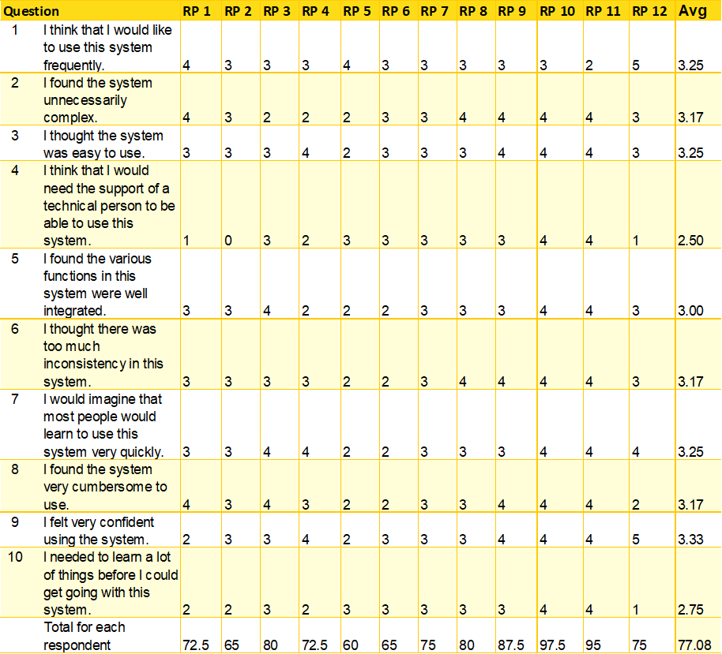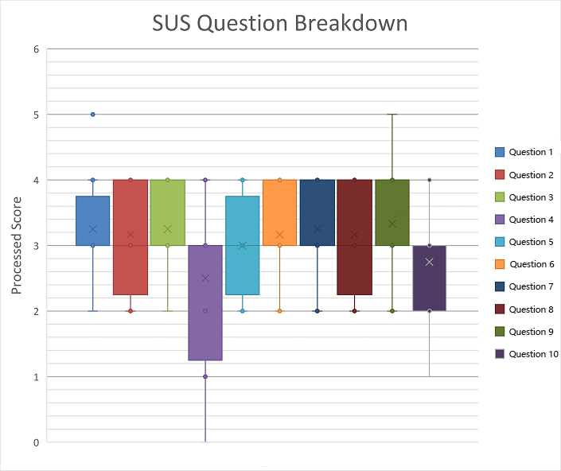

*System Usability Scale: Processed Data Table*

*System Usability Scale: Box and Whiskers Graph by Question*

High Fidelity Prototype

In this section, the team revised the conceptual design and the prototype based **on more research and the feedback collected from the medium prototype evaluation**. The key features and function of the prototype were not changed. Instead, more interaction processes and images were added to this prototype.

**Revised Requirements**

**System Concept Statement (Revised)**

This revised system concept statement focuses more on fluency and connectivity of login functions, the feasibility of adding bill function, paying function, and finance courses function because these functions receive more feedback from the evaluation. There will be more interaction processes in other functions, including checking bills, checking budgets, coupons, analysis tables, personal details, and setting functions.

**Updated concept statement:**

The Bookkeeping app provides users with a range of easy-to-use features that can help them save money, while it also offers different money-saving courses, coupons in different categories, and a community where they can share their money-saving content aimed to help those people who want to save money.

**Changes based on the evaluation of the mid-fidelity prototype:**

* Add more login ways.
* Show the user’s profile picture and name at the top of the main page.
* Text and button displayed in the menu bar at the bottom of the page has been made larger.
* The icon color at the main page has changed close to the theme color(eg: Yellow theme with orange icon).
* “Return” at each page has changed to a back arrow.
* Checking bill page now can view bill details for different years and months
* Budget page now can change the budget plan.
* Add Shopping cart features in the finance course page.
* Add descriptions, photos, and categories to the coupon.
* Put settings in every main function page.
* The ranking list can be sorted selectively
* Add bill detail was changed to shown when the user clicks one of the category buttons.
* Available to follow a person and share with friends in the community page.
* Add the result page when a person makes a post in the community page.
* Change the button and text color when the theme color was changed.
* User profile page only displays the total budget, your finance class and managed bank card.
* “Log out” was changed to the exit icon at the main page.
* Add more result pages and intermediate pages.
* Change “Date of birth” to “Repeat Password” in the register page.

**Design Guideline (Revised)**

In this session, the team revised the design guideline of the prototype, the changes from the medium prototype evaluation are highlighted in bold.

**Interface design**

* Because this application is used on mobile phones, the interface must be simple and easy to operate.
* All the buttons or icons should be easy to notice and easy to click by hand.
* Because a user might use this app for an extended period, the color scheme should be bright, not make people feel uncomfortable, and the font size should be appropriate, so it will not make the user's eyes tired after long watching.
* Make sure the consistency of the interface design. In addition, the function must be clear, and the operation must be easy to save the user's time.
* **Include more metaphor icons instead of words(eg: Return function, Logout function) (From Think Aloud Result)**
* **Prevent duplicate information display (From Appendix 1.3, Question 13.3)**
* **Icon and text color should match the color of the theme (From Appendix 1.3, Question 10.2,10.3)**
* **The word explanation for each function should be clear and easy to understand(From Appendix 1.3, Question 2.1, Question 4.4)**
* **The icon metaphor should match the function.(From Appendix 1.3, Question 13.1)**

**User privacy and security**

When obtaining primary user and bank accounts information, please protect user information and prevent leakage. In this application, users need to set up a PIN (personal identification number), so when users want to pay, they need to enter their PIN, which is only known by themselves. This will improve the security to a great extent, and users can use the application more confidently.

**Custom function**

Ensure that users can customize their own types of bills in the adding bill function, they can customize the name and the picture of the bill category so that they can create an adding bill page that they feel more comfortable with and more willing to use this feature and this application to save money.

**System capabilities**

The most important job of this app is to help people save money. Therefore the bill and the budget situation are their most concern. In this app, a notification can remind users if they spend over budget and how much money they left from their budget, so users do not have to check their bill at any time by themselves, which can reduce their stress.

**Collect opinions**

Having a good user experience will attract more users and improve the time they spend on our application. In order to achieve this goal better, make sure there is a way for the users to give their opinions, thoughts, and suggestions for this application. By using their feedback, the app will constantly improve their user experience.

**Interaction Process & Result(From Appendix 1.3, Question 1.2,1.3,8.4)**

Having an interaction page after each action, such as pressing a button or adding information, will make the interaction more fluid and improve the user experience. In order to achieve that goal, there will be a result page after each interaction that tells the user what they are doing is right or wrong, so it reduces their confusion.

**System Requirements (Revised)**

**Old System Requirement Function that still apply in high prototype**

|  |
| --- |
| Interface operation  Apps should have simple and clear operating instructions, easy to be noticed and operated by hand.  Rational: Users mainly use this application on their mobile phones, so function with simple and straightforward operation with fewer operating errors will bring users a better user experience.  Notice: “Frequent errors in operation makes me feel frustrated”- Suitable icons and font size make the operation easier and more comfortable. |
| Notification function  Notification about users’ bills, budget and finance courses.  Rational: Users may worry about whether they are over budget or need to attend class, and they need to check their app frequently without notice, so the notification function will tell them the information and help them reduce the stress, which will save them much time.  Notice: “Constantly checking my bills on this application makes me tired” - Notification messages reduce the number of time users spend reviewing their bills. |
| Security function  Protecting users personal information especially the details of the bank account and their money.  Rational: Users will band their bank cards or other payment methods on this application, so they are concerned about their account and money security. A security function will make them trust more on this application.  Notice: “Sometimes I am worried about if my bank details are leaked when using money-saving apps” - A PIN(personal identification number) will be needed when someone wants to pay or check their personal information. In this way, users will feel at ease using this app. |
| Sharing function  Share to Facebook/Wechat friends  Raional: Users may want to know how their friends are saving money, or they may want to share their tips with friends. That is where this function will be helpful for them.  Notice: “If I can share experience with my friend on this app, I will use this app more often ” - Sharing online will attract people to use this application. |
| Bill function  App users are allowed to add their spending and income in this app.  Rational: In order to save money the app needs to track their bills so users can see how much they spend and how much they left and make adjustments.  Notice: Bills have different categories, and users can choose to customize them. If the user adds a bank card, the app can automatically track every expense and entry in the card. |

**New System Requirement function**

|  |
| --- |
| Multiple way to login  App users are allowed to login this application through different ways  Rational: In order to give a user a more satisfying user experience and feel more flexible operation, the app needs to provide multiple login paths, including WeChat, Facebook, Google, and PayPal accounts, because some users want to avoid registration or login process.  Notice: “You can use the app with payment function and real-name authentication to log in and bind, which is beneficial to the user's personal information and back-end bill binding.”  **（Appendix1.2, Question 1.3）** |
| Budget function  App users are allowed to set and change a budget plan.  Rational: In order to save money, users need to set a budget plan to limit their spendings, and they also need to change the plan if they find the budget plan is not suitable for them.  Notice: “After setting the budget, if the user wants to change the budget, the user can modify it .” **(Appendix 1.3, Question 5.1)** |
| Shopping cart function  App users are allowed to add courses to the shopping cart and buy all the courses in the shopping cart at the same time.  Rational: Users may not want to buy only one course at a time, and it might be a waste of time for users, so in order to improve their user experience at purchasing courses process, a shopping cart button and page are created so users can add their favor courses into the shopping cart list and remove the courses they are not interested. Finally, the users buy all the courses at the same time.  Notice: “There should be a shopping cart button, so users don’t need to buy one by one.” **(Appendix 1.3, Question 8.1)** |
| Clear the way to pay for a course  App users are telled how they can purchase a course in different ways.  Rationsal: The user experience will be improved if users find that they have more choices, this app will allow users to purchase a course through their money or through the points they get by clocking in this app. They can achieve that by clicking on the switch button beside the price.  Notice: “There should be two options (the drop-down box has points and money).” **(Appendix 1.3, Question 8.5)** |
| Discount function with detail information  App users are allowed to choose different types of coupons and get the detailed information about it.  Rational: Although users want to save money, it is unavoidable to buy the necessities of daily life. Therefore, it is very useful to help users reduce this part of the cost. This app provides several coupons. Users can see the detailed information and find coupons through different types on the category page.  Notice: “Need detailed coupon usage rules, such as how do I use these coupons and where to use them (you can pop up a prompt as soon as you enter the page, or display the introduction after the purchase): the page is more detailed.” **(Appendix 1.3, Question 9.2)**  “There is no classification for people and categories (eating, drinking, and having fun).” **(Appendix 1.3, Question 9.3)** |

High-Fidelity Prototype

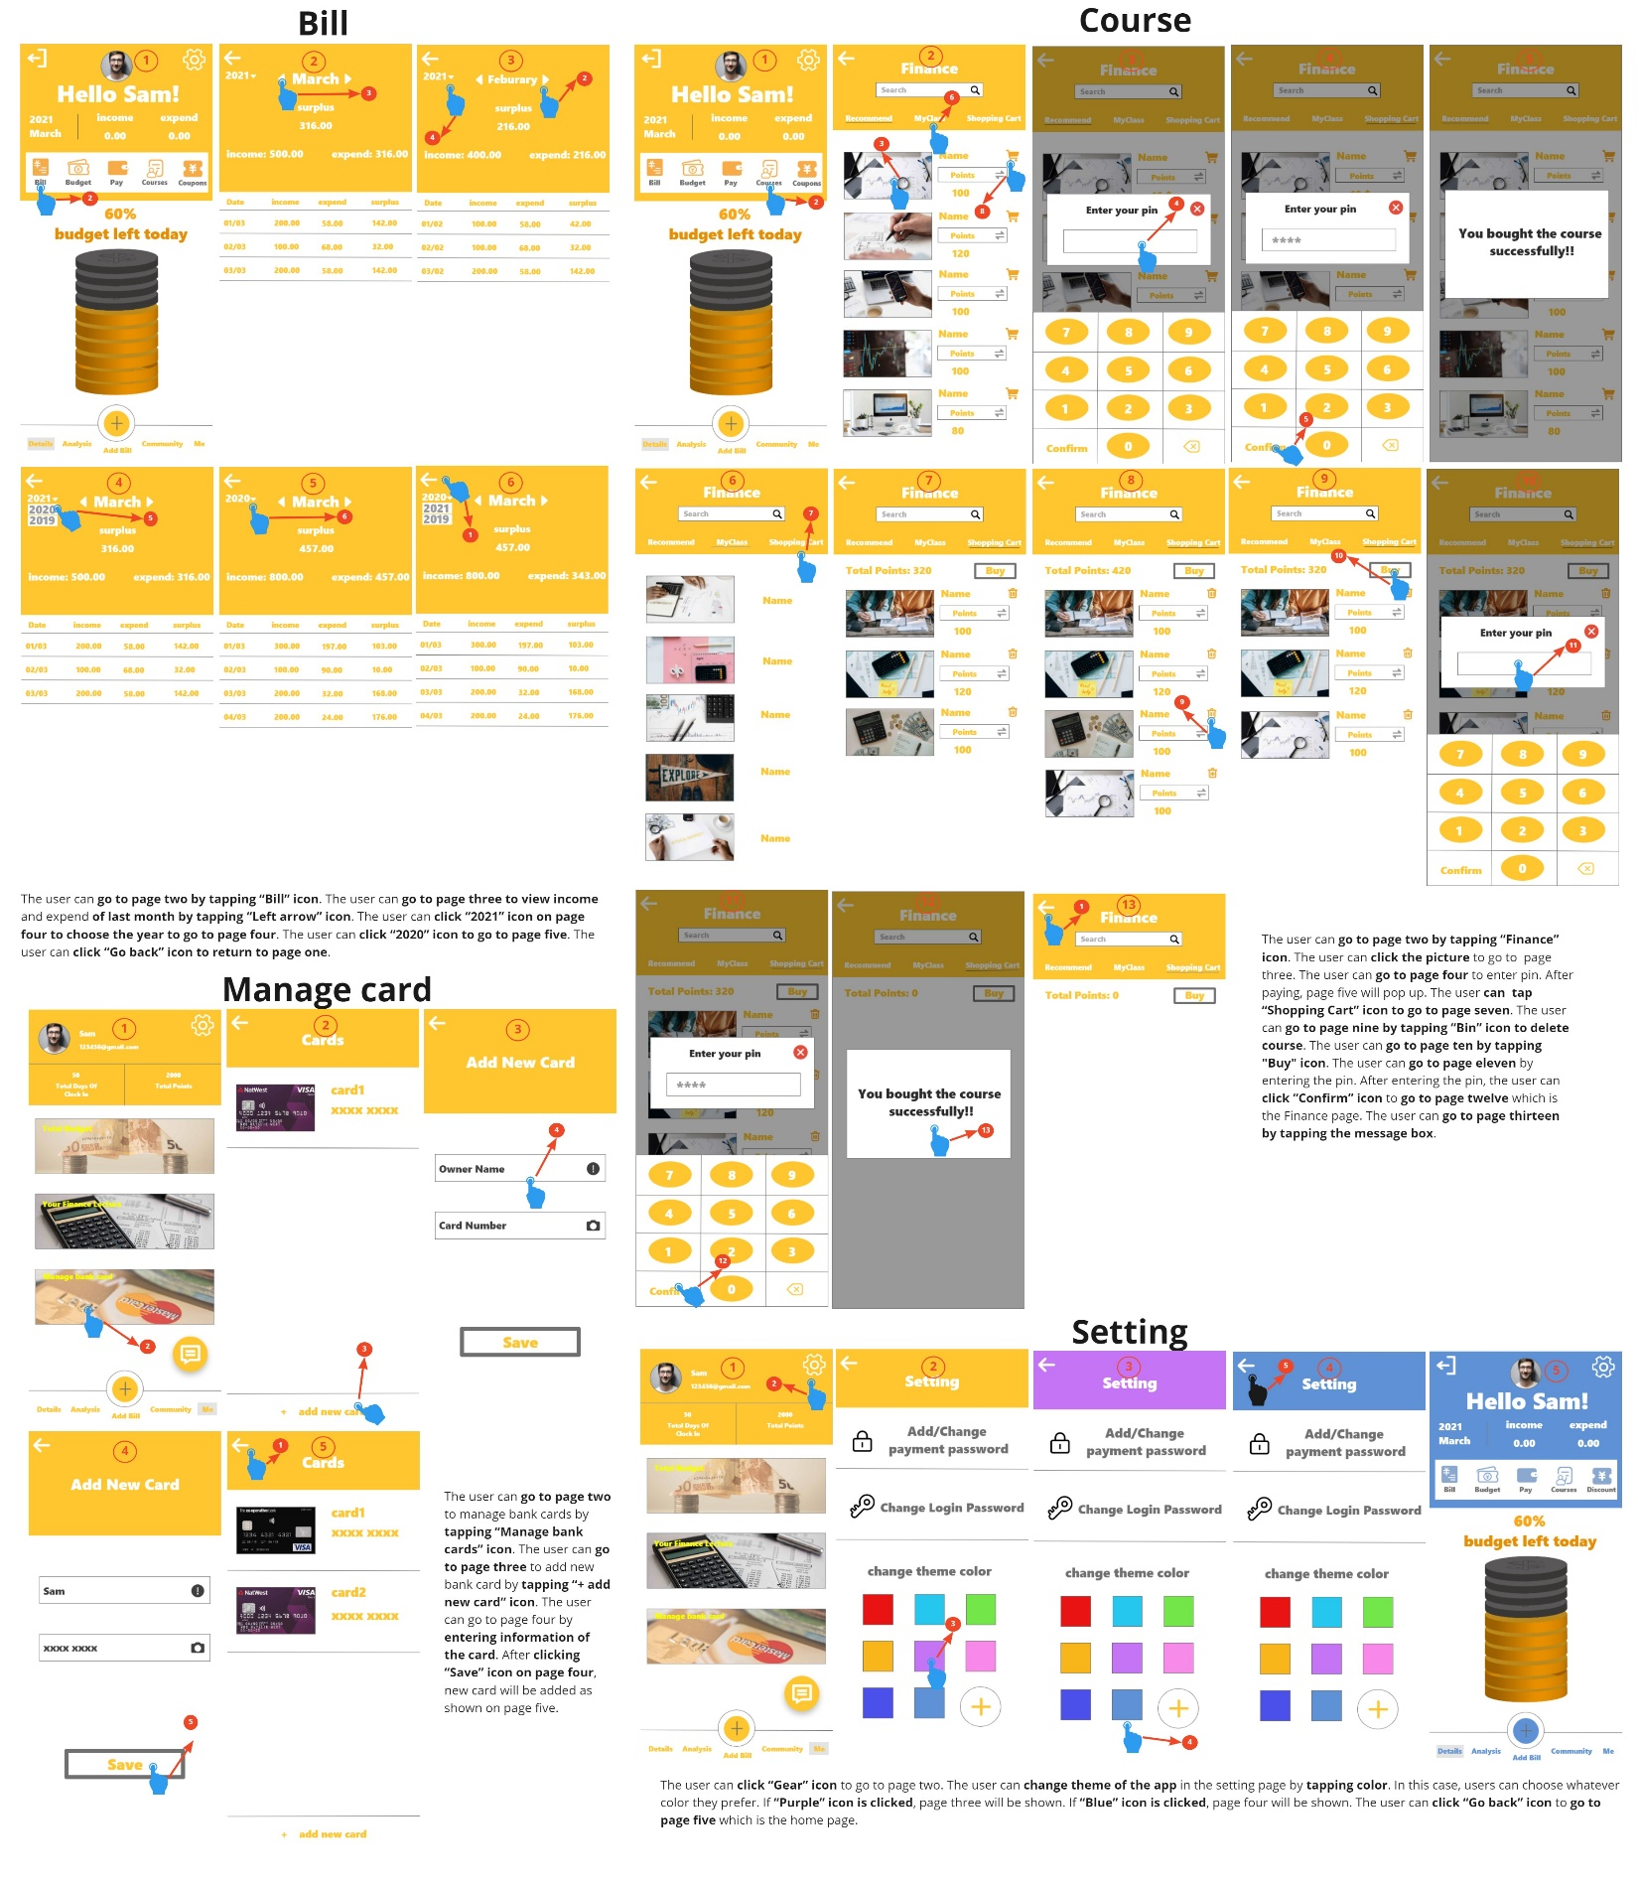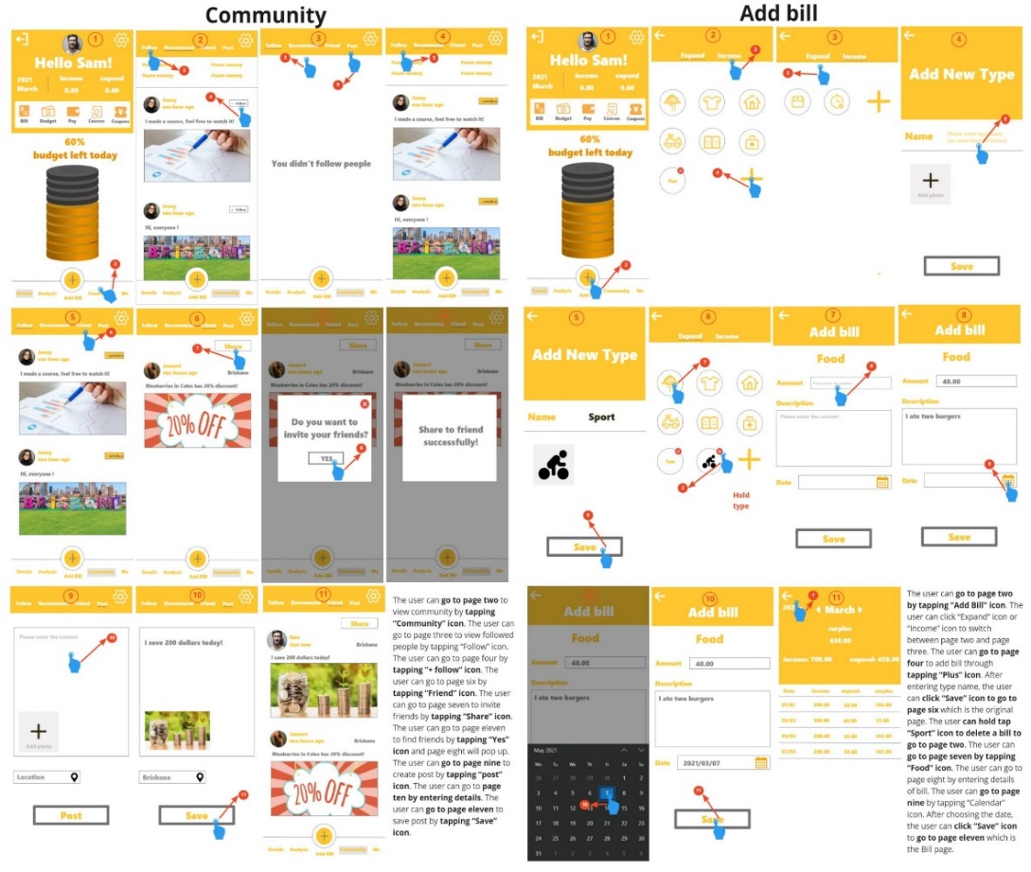

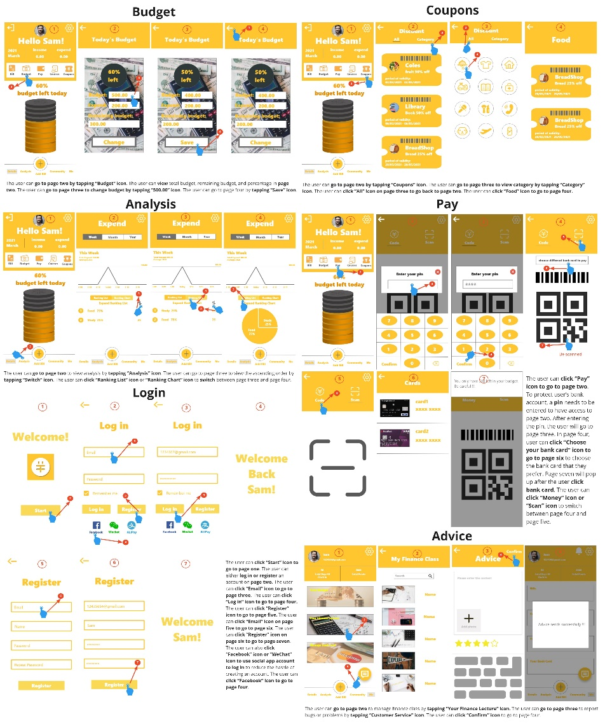

High-Fidelity Prototype Evaluation

The content of this part will focus on the evaluation of high-fidelity prototypes. The high-fidelity prototypes are improved based on the evaluation results obtained from the mid-fidelity prototypes. Therefore, this part of the evaluation is to check whether the prototype of the improved application conforms to the concept of human-computer interaction, and this is also the last prototype-based evaluation. In this evaluation, we invited 6 human-computer interaction experts and 9 target users. These experts can use the principle of interaction to better help us find the good and bad qualities of the design and determine whether it has problems.

**The evaluation methods we used include:**

* Technology Acceptance Model (TAM)
* Heuristic evaluations
* Pluralistic walkthrough

**Evaluation process**

The evaluation process of the high-fidelity prototype will be carried out according to the protocol in Appendix 2,0. We will explain our improved protocol to users and introduce the evaluation process to ensure that the evaluation of each participant is consistent. The invited experts and target user groups will give different types of feedback for different evaluation methods. These feedback results will be used for analysis and discussion, but will not be displayed in this prototype. Finally, we will sort out basic conclusions and possible solutions based on the results of the analysis.

Detailed Evaluation Methods 3

**Technology Acceptance Model (TAM)**

**Background of TAM**

The Technology Acceptance Model (TAM) aims to measure the adoption of new technologies based on the attitudes of users(Allen, 2020). Users' attitudes towards new technologies are mainly divided into four categories, namely, perceived usefulness (PU), perceived ease-of-use (PEOU), attitude towards technology (ATT) and intention to use (ITO). Perceived usefulness is a measure of the degree to which users find a particular system useful when working with it. Perceived ease-of-use is a measure of whether users think it is easy for them to use a particular system. Attitude towards technology is a measurement method based on perceived usefulness and perceived ease of use. It mainly detects users' attitudes towards new technologies, that is, whether they accept the technology. Finally, the intention to use is based on all the above directions to measure the possibility of users using this technology in the future.

**Evaluation process of TAM**

Before starting the evaluation, we introduced the operation process of TAM and the concept of our application to the users, and allowed them to simply operate the high-fidelity prototype we provided them before filling out the questionnaire. The user's operation should not be too complicated. After that, users will complete the questionnaire. The maximum score for each question is 4 points, and the scores given by users will be integrated and analyzed at the end. (Appendix 2.1)

**Reasons for using TAM**

We chose this evaluation method because the current evaluation stage has reached the high-fidelity prototype evaluation, and all functions and interaction models are basically in a relatively complete state. At this time, testing whether the user can accept such a design concept will more accurately reflect the acceptance of our prototype in the user group and the user's attitude. In addition, the questionnaire model allows us to better analyze those problems.

**Result Presented**

In this evaluation method, the highest score for each question is 4. If the user chooses 4, it means that they are most satisfied with the content of the question. If the user chooses 1 point, we will further ask him the simple reason for not accepting the point. During the analysis, all results will be displayed in the form of graphs, including the score distribution and average score for each question.

**Limitation of TAM**

The lack of a consistent process during testing can easily lead to the omission of details, and all users' ratings are based on their ideas, rather than being completely objective and fair. Finally, since TAM only provides quantitative data, more information is needed.

**Heuristic evaluations**

**Background of Heuristic Evaluations**

The main purpose of heuristic evaluation is to discover and identify any problems related to user interface design. Rolf Molich and Jakob Nielsen developed this method based on their years of usability engineering teaching and consulting experience (Wikipedia contributors, 2021). The time required for heuristic evaluation varies with the complexity of the task and the ability of the evaluation expert. Since this method requires interaction experts to evaluate, the designer will choose a set of evaluation criteria for them.

**Evaluation process of Heuristic Evaluations**

In the heuristic evaluation phase, we will first provide experts with our protocol and introduce our high-fidelity prototype. Then we chose "Jakob Nielsen's 10 general principles for interaction design" (Nielsen, 1994) as our evaluation standard, and asked experts to evaluate the design and interface of our 8 main functions. Experts should interact with our prototype in depth before evaluation. Finally, the experts will discuss the types of detected problems and make recommendations. (Appendix 2.2)

**Reasons for using Heuristic Evaluations**

This is a new evaluation method, which is different from the method used in the mid-fidelity prototype. Heuristic evaluation has prescribed evaluation criteria. After experts use these criteria to evaluate, the designer can learn about the design interface and Usability issues. To a certain extent, the results obtained in this way are more objective and have certain standards than the results obtained by ordinary user tests.

**Result Presented**

After the discussion, the expert will give the corresponding violation principles for the problems found, and point out the impact on the user and the severity level. These data will be filled in the form in a unified form for easy viewing.

**Limitation of Heuristic Evaluations**

Although heuristic evaluation can find many major usability problems within a certain period of time, the results are still affected by the knowledge level of experts (Wikipedia contributors, 2021). And it’s still easy to overlook important issues, so it’s not entirely scientific.

**Pluralistic Walkthrough**

**Background of Pluralistic Walkthrough**

Pluralistic walkthrough is to achieve the purpose of evaluation by collecting feedback from a group of users or stakeholders. The conclusion of the evaluation is based on the suggestions made by the participants after completing the tasks provided by the designer. This is an iterative group evaluation (Bias, n.d., 1994). During the evaluation, the designer will discuss with the target user group to determine the available data and conclusions.

**Evaluation process of Pluralistic Walkthrough**

Firstly, we will present our protocol to participants and provide a set of tasks based on the main functions of the application. Users or stakeholders will leave their own feedback when completing these tasks. During this process, we will communicate with them and obtain the reasons why users generate these feedbacks. (Appendix 2.3)

**Reasons for using Pluralistic Walkthrough**

Pluralistic walkthrough can clarify the design interface and standards required by the user by analyzing the user's suggestions for the set tasks. The evaluation is user-centric. At the same time, designers can use the feedback obtained to discuss design problems with users in a timely manner and find solutions.

**Result Presented**

The results obtained will be classified and sorted according to different tasks, and possible effective solutions will be found.

**Limitation of Pluralistic Walkthrough**

Due to the progress of the participant's evaluation task is different, it may take a certain amount of time. And it is difficult to arrange a large number of users, stakeholders and experts at the same time. In addition, because there is a set of tasks, participants cannot freely explore the prototype.

Analysis Results 3

**Technology Acceptance Model (TAM) Results**

According to figure 3, we can clearly see the average score of each question. In general, there are 11 questions with an average score of 3 or more, which shows that although the design concept of our prototype cannot be strongly accepted by users, it can be generally accepted by them. Therefore, in terms of design concept, our prototype can still meet the basic perception needs of the public.However, we still have four questions that scored less than three points, and one of them is even less than 2 points. They are, PU2: "I can accomplish my saving money plan more easily using this app."; PEOU1: "Learning to use this app is easy for me."; ATT1: "In my opinion, it is desirable to use this app ."; ITO2:"I will frequently use this app in the future."

By combining Figure 4 and Figure 5, we found that all participants rated the four questions roughly the same, and it was not because a participant’s score was too low that the average score dropped. For PU2, 3 users filled in 2 points and 6 users filled in 3 points. When asked why they were not given a higher score, their answer was that when experiencing this application, relying only on the description of the concept would make some functions difficult to understand and increase the difficulty of using it. For PEOU1, 7 participants filled in 2 points and 2 participants filled in 1 point. When they were asked why they gave such a low score, most of them thought that there were too many functions in the applications, and because some functions do not make all the interactions, it is difficult for users to learn to use these functions immediately without in-depth research. A small number of people think it is caused by their own understanding ability, but they still hope that each function can have a basic introduction.

For ATT1, 6 users filled in 2 points and 3 users filled in 3 points. At the same time， for ITO2, 2 users filled in 2 points and 7 users filled in 3 points. It is not difficult to find that users who gave low scores in these two questions also gave low scores in PEOU1. They all pointed out that the main factor affecting their score on these two questions is that they think it is not easy for them to learn to use this application, which is the question of PEOU1.

Therefore, we have found that if we want to improve users’ attitudes and intentions towards new applications, we must improve aspects that affect the perceived usefulness and perceived ease-of-use of new applications.

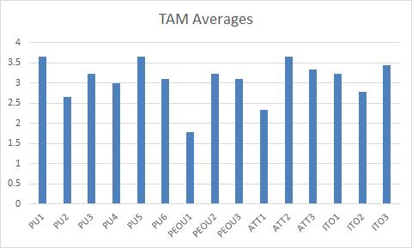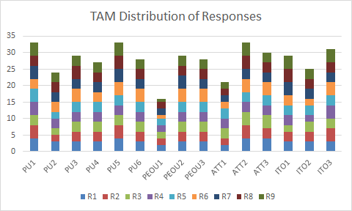

Figure 3: Average score on each question (TAM) Figure 4: TAM distribution of participants’ responses

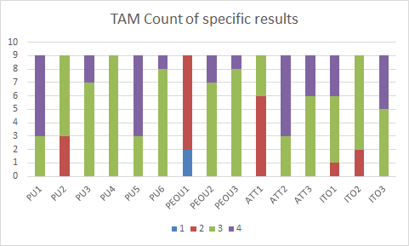

Figure 5: Count of specific results for each question (TAM)

**Heuristic Evaluations Results**

All the evaluation results have been filled in in the table below. It can be seen from the results that there are some problems with some major functions, including the interface. I will analyze the conclusions that have a significant impact on the prototype and give possible measures.

|  |  |  |  |  |  |  |  |
| --- | --- | --- | --- | --- | --- | --- | --- |
| **Screen/element description** | **Usability issue** | **Heuristic category** | **Probable effect on user** | **Freq** | **Imp** | **Per** | **Severity rating** |
| Budget page - change budget | Action for saving change is unclear | Visibility of system status | Confused about whether the modification was successful | common | low | not | 2 |
| Login page - different ways to login in | Feedbacks from different social media logins are the same. | Error prevention | This makes the user unsure if he/she login in with the correct social media. | common | low | very | 3 |
| Budget page-Today’s budget | The color match between the picture and the text is not clear. | Aesthetic and minimalist design | Prominent background makes it difficult to read text. | common | low | not | 2 |
| Add bill - add new category type | Unable to reselect images/text when adding categories. | User control and freedom | Take more time to finish this step. | common | low | very | 3 |
| Course - my class | Cannot delete purchased courses. | User control and freedom | Inability to manage their courses flexibly. | common | low | very | 3 |
| Manage bank card - add new Card | Remove bank card function is missing, users can only add a bank card card not remove a card card. | User control and freedom | Inability to manage their bank card | common | low | not | 2 |
| Pay - Code and Scan | The notification of payment is not clear. | Visibility of system status | Confused about how much money he spends after payment. | common | low | not | 2 |
| Bill | The button to change the year is not clear. | Aesthetic and minimalist design | The user cannot find where to switch the year. | common | low | not | 2 |
| Detail - logout location | The location of the logout is not consistent with the user's usual perception. | Consistency and standards | Feeling uncomfortable with the design | rare | low | not | 1 |

## 

## Based on the corresponding heuristic category of problems raised by all experts, the problems of our high-fidelity prototype are specifically reflected in these three aspects: "visibility of system status", "user control and freedom" and "aesthetic and minimalist design". These aspects mainly show that our high-fidelity prototypes still have some deficiencies in page design and interactive guidance.

For the budget function, after successfully changing the "Today's Budget", we can pop up a prompt box to inform the user that the budget has been modified successfully, so as to prevent the user from not knowing whether the budget has been successfully changed. Secondly, we can change the background image of the budget interface to a lighter-colored image or a contrasting image with the text to ensure that users can easily distinguish the area of the text. Add a prompt box to the login interface to confirm to the user when using different methods to log in. When adding a bill category, adding a delete flag gives the user the freedom to change the icon and text. This method is also suitable for the management of purchased courses. Finally, the way to improve the payment function is to display the remaining budget and the amount spent in the prompt box that pops up after consumption, so that users can see their expenditures more clearly.

**Pluralistic Walkthrough Results**

**Task 1**

As a new user, participants want to be able to log in in different ways and be prompted before logging in, for example: Are you sure to log in using Facebook? If the user clicks "Cancel", the login operation can be cancelled. If the login is successful, they will receive a pop-up notification of successful login after they log in. The use of these methods is to prevent users from misoperation, and they are also functions that are not currently added to our high-fidelity prototypes.

**Task 2**

Regarding the function of viewing bills, users want to see a clear list of bills, including income, expenditure and remaining amount. There must be a clear currency unit after the amount, this is to let users know the amount of their own expenses (for example, the U.S. dollar and the Australian dollar are not the same). Finally, click on the specific date in the bill to view the type of expense and the details of the expense. In general, they think that the existing billing function is useful, and what needs to be added is the currency unit and the type and details of expenditure.

**Task 3**

Participants want to see the budget they set and the icon that can change the budget on the budget function page. And hope that after changing the budget, they will see a successful change prompt so that they can confirm that they have successfully changed today’s budget. At present, the budget function in the prototype has added an operation icon to change the budget, but the aspect that may confuse users is that there are input boxes under all amounts, and make them unclear which amounts can be changed. At the same time, after successfully changing the budget, we did not add any hints. Finally, participants pointed out that the background image of the budget function is too complicated to allow users to see the text. These changes will be implemented in the future.

**Task 4**

They hope to use face id or touch id for payment and interface verification when using the payment function, and be reminded of the amount spent after consumption. In our prototype, the interface verification is performed through a pin, and the user is only told what the remaining budget is after consumption. Therefore, the function of the prototype can be combined with the user's opinion to realize the payment function that the user expects to see.

**Task 5**

Participants want to see the introduction of the course content, the provider's information and other people's evaluation of the course on the purchase course page to ensure that the course they purchased is useful and reliable. Similarly, after purchasing a course, a pop-up window will appear to indicate that the purchase is successful, and users can jump to the details page to learn it directly. At present, our course page only has a recommendation page, purchased course page and shopping cart function. The content mentioned above has not been considered, so these suggestions will be very good inspirations.

**Task 6**

Participants mostly want to see cash coupons or shopping discount coupons, and they also want to see the instructions after clicking on the coupons. For different types of coupons, they hope to have text descriptions on the surface of the coupons. In the high-fidelity prototype, all shopping coupons have been placed in categories, but no instructions have been added. Therefore, we can add instructions and detailed classification to the coupons in the future.

**Task 7**

The add bill function in the current prototype basically meets the expectations of the participants. The only thing that needs to be noted is that the participants hope that after clicking the category, the billing table will appear at the bottom of the page instead of jumping to a new page, which can make it more convenient for users to change classification. This is also a problem that has been modified many times in the mid-fidelity prototype.

**Task 8**

Participants want to see their friends' posts in the community. The content of the posts includes their money-saving methods and whether they have completed their money-saving goals. In addition, they also hope to interact with their friends, such as likes, comments, etc. Regarding the recommended posts, they hope that these posts can be more useful. The current high-fidelity prototype does not support users to comment on friends' posts, but these changes will be referenced in the future.

**Task 9**

In the high-fidelity prototype, the function of changing the theme color basically meets the user's expectations. However, they believe that if the theme can be divided into day mode and night mode, and the background image and theme function bar color can be customized, it will be more attractive.

**Conclusion**

This report mainly provides feedback on the improvement process and multiple evaluations of the bookkeeping prototype. After the prototype has gone through three iterations, the high-fidelity prototype of the design team has gradually tended to be an application prototype that can be developed. In the final evaluation, we received feedback from experts and stakeholders. These results made our prototype concept no longer limited to the subjective ideas of ordinary users. However, there are still some problems in high-fidelity prototypes. Most of them are distributed in interactive reminders and page design, such as lack of operation prompts, lack of result prompts, and page design that cannot be easily understood by users. There is also some content that has not been taken into consideration, such as how users with mental or visual impairments use our app. In the actual development in the future, these problems may be solved one by one.

Appendices

**Appendix 1.0 Medium-Fidelity Prototype Protocol**

**Introduction**

We are team Main() and we are trying to develop an app for the DECO2500 project. Our project is mainly focused on designing and developing an app to change these people's spending and saving money behavior. Bookkeeping is a money saving app that allows people to set their budget, track their weekly, monthly, yearly spending, give feedback and suggestions on saving more money, and provide finance courses to help people learn how to save money.

In this process, we will get your feedback on your user experience and the usability of this application. We would like to know if you have any difficulties in using this application if you have a good understanding of the interaction process, and whether there are any problems with the interface and functionality.

**Consent**

For today’s evaluation, we will use Design walkthrough, Think Aloud and System Usability Scale(SUS) Evaluation methods. The purpose of this task is to get your opinions and evaluate this application, not assess you, so we can use your feedback to improve our medium fidelity prototype. This is a voluntary task. Feel free to stop this task at any time if you feel uncomfortable in the evaluation testing session.

**Appendix 1.1 Design Walkthrough**

**Task1- Design Walkthrough**

The first task for today is a Design walkthrough.

We will ask you to complete a series of different tasks relevant to the application’s functionality and usability during this evaluation. Your jobs were doing the tasks through our prototype by yourselves, and we will ask you questions when you face some problem, or something did not happen as we expect. We will record your response and generate it in a document. These records will not be used for any other purpose. Feel free to ask any questions while doing the evaluation. Do you have any questions about the task you are about to complete?

Here are the following tasks we would like you to complete today:

1. “Go to the login page and try to use WeChat/Facebook or register to log in.”
2. “Find monthly bills and daily bills on the main page, and try to add new bills.”
3. “Customize a category in the bill category and try to delete it.”
4. “Set a password for the second payment and try the scan code payment function. Try to choose a different bank card to pay.”
5. “Check today’s budget and find the page that reminds you of the remaining budget”
6. “View the weekly spending ratio table and view the list or pie chart according to your favorite presentation method”
7. “ Browse the community, try to post a new post, and see what a friend posted.”
8. “ Find the finance class page and try to purchase a course. Find the purchased course on the personal information page.”
9. “View discount coupons”
10. “Try to change the theme color of the app/Try to change the function icon.”
11. “View the weekly total budget report and remaining budget.”
12. “Try to add a new bank card. Check the bank card you have added.”
13. “Try to give comments and feedback to our app.”

**Task Details**

1. “Go to the login page and try to use WeChat/Facebook or register to log in.”
2. The process they try to login by using wechat/facebook button
3. Their opinion of the login interface
4. Their opinion of the login process.
5. “Find monthly bills and daily bills on the main page, and try to add new bills.”
6. Take note on how users find the monthly bill page.
7. The process users add new bills.
8. Their opinion of the monthly bill interface.
9. Their opinion of adding new bills.
10. “Customize a category in the bill category and try to delete it.”
    1. The process users add a new category
    2. The process users delete a category
    3. Their opinion of the bill category interface.
    4. Their opinion of the add/delete category process.
11. “Set a password for the second payment and try the scan code payment function. Try to choose a different bank card to pay.”
12. The process users set a pin
13. The process users choose a bank card to pay.
14. Their opinion of the set pin process.
15. Their opinion of scan code interface.
16. Their opinion of the scan code payment function.
17. Their opinion of choosing a different bank card process.
18. “Check today’s budget and find the page that reminds you of the remaining budget”
19. Take note on how users find the budget page.
20. Their opinion of the budget page interface.
21. Their opinion of the remaining budget function.
22. “View the weekly spending ratio table and view the list or pie chart according to your favorite presentation method”
23. Take note on how users find the ratio table.
24. Their opinion of the ranking list/ pie chart interface.
25. Their opinion of the ranking list/ pie chart function.
26. “ Browse the community, try to post a new post, and see what a friend posted.”
27. Take note on how users find the community page.
28. Their opinion of community interface.
29. Their opinion of the post function.
30. Their opinion of the friend post page.
31. “ Find the finance class page and try to purchase a course. Find the purchased course on the personal information page.”
32. Take note on how users find the finance class page.
33. Their opinion of the finance class page interface.
34. Their opinion of the purchased course function.
35. Their opinion of the personal purchased course function.
36. “View discount coupons”
37. Take note on how users find the discount page.
38. Their opinion of discount coupons interface.
39. Their opinion of discount coupons function.
40. “Try to change the theme color of the app/Try to change the function icon.”
41. Take note on how users find the button to change theme color.
42. Their opinion of changing theme color function.
43. “View the weekly total budget report and remaining budget.”
44. Take note on how users find the total budget report.
45. Their opinion of the total budget report interface.
46. Their opinion of the total budget report function.
47. “Try to add a new bank card. Check the bank card you have added.”
48. Take note on how users find their bank card.
49. Their opinion of adding new bank cards function.
50. “Try to give comments and feedback to our app.”
51. Take note on how users find feedback pages.
52. Their opinion of giving comments and feedback interface.
53. Their opinion of giving comments and feedback functions.

**Appendix 1.2 Thinking Aloud**

**Task2- Thinking Aloud**

**Our second task is Thinking Aloud.**

After you finish the design walkthrough task, we would like you to finish the Think Aloud evaluation test. In this session, you need to give your thoughts, feelings, and opinions of our project based on your user experience and interaction with our project. Your response will be recorded and generated in a doucment. These records will not be used for any other purpose.

Do you have any questions about the task you are about to complete? Now let’s do the next task.

**Appendix 1.3 System Usability Scale(SUS)**

**Task3- System Usability Scale(SUS)**

Our final task for medium fidelity prototype is System Usability Scale(SUS)

For the last part, you will need to finish a survey which contains ten questions asking the usability of our project. These questions have five choices ranking from strongly agree to strongly disagree. You need to give your choices based on your user experience from the first two evaluation tasks. Your response will be collected in a template and the result will be processed into a score for us to analyze.These results will not be used for any other purpose.

Do you have any questions about the task you are about to complete?

**Appendix 1.4 Design Walkthrough Process**

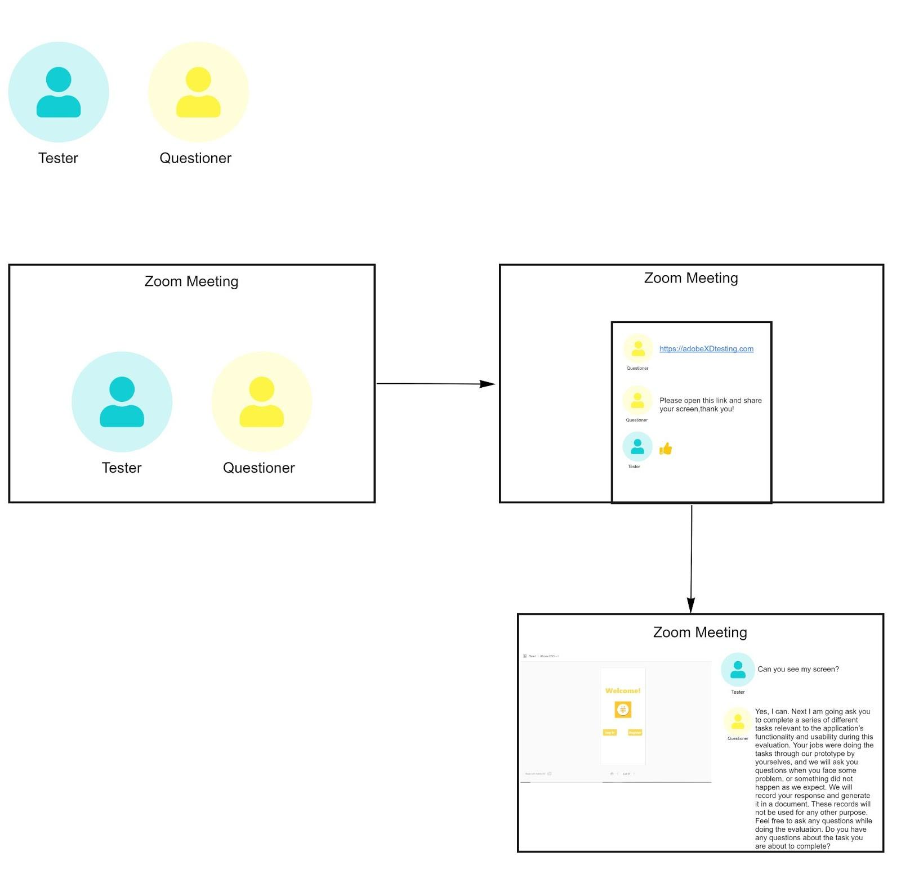

**Appendix 1.2.1 SUS Result**

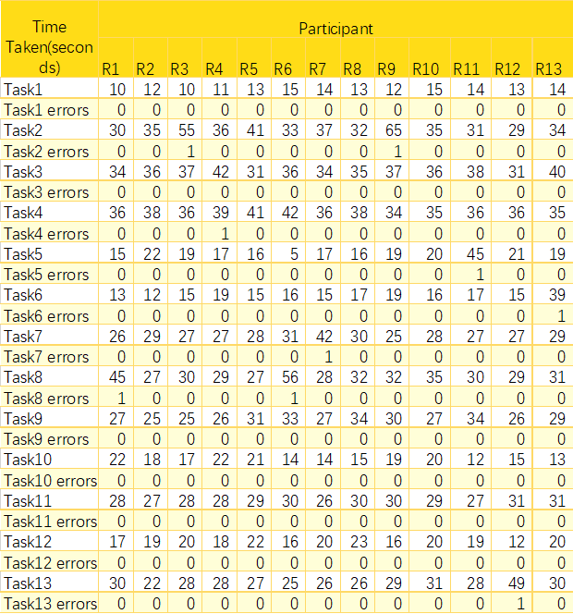

**Appendix 1.3.1 Thinking Aloud Result**

|  |  |  |
| --- | --- | --- |
| **Question Number** | **Feedback Number** | **Feedback Detail** |
| 1 | 1.1 | If I use Facebook/WeChat to enter the page, the main page should have a corresponding avatar and username to remind me which login I am using, which will be clearer. |
| 1.2 | The login page can be kept as the cover, and the two buttons on the homepage are combined into one, and then there is a register button in the login page.  It is better to have interactions and clicks on the register/login page in high, and there is a second confirmation password input during email registration. (have a result page) |
| 1.3 | You can use the app with payment function and real-name authentication to log in and bind, which is beneficial to the user's personal information and back-end bill binding. (One more login way) |
| 2 | 2.1 | Bill changed to Statement. |
| 2.2 | Hope that the bill can be viewed according to the date selected by the user.E.gif a user select the bill for March, in addition to displaying the total cost and deposit for the entire month of March, user should display the bill for each day in March at the bottom (like the WeChat bill) and change the bill to monthly. Choose left and right, and then the daily statement below. |
| 2.3 | After clicking complete, the user can jump directly to the current day's bill. Users don't need to go to the main page to find it. The current method is a bit cumbersome. |
| 3 | 3.1 | It is better to circle away, then enlarge the plus sign. |
| 3.2 | The calculation keyboard is separated from the calendar (if it is a computer). The calendar option can be placed after selecting the description: three or two rows, description->Calendar->Amount->Keyboard for entering the amount. |
| 3.3 | User-defined icons are only a bit obtrusive for text, and it may be better to add custom pictures. |
| 3.4 | The add bill page should only have the category icon and description, and the keyboard with the date of adding the amount will be displayed after clicking on the specific category |
| 4 | 4.1 | Login password may overlap the concept of pin, and can be changed to payment password (pin). |
| 4.2 | I don’t know what the bank card is used for, and the instructions become more clear. choose a different bank card to pay. |
| 4.3 | Although most people know that the setting may be on the personal information page, it is still difficult to find it (all three of them). I hope that the setting can be placed on the homepage or the upper right corner of each page to make it more convenient to use (except for the function page clicked in ) (the following three pages have setting icons). |
| 4.4 | The meaning of the text "money" displaying the QR code in Pay is unknown, it can be changed to code. |
| 4.5 | Failure to enter the page if the word scan is not selected, it can be changed to click the icon to jump to the page. |
| 5 | 5.1 | After setting the budget, if the user wants to change the budget, the user can modify it . |
| 5.2 | The word “Budget left” is black, which is the same as the color used on the icon. At first glance, what I thought was black is the remaining; the budget page reminds the user that it is today's budget instead of total (all changed to the color yellow). |
| 5.3 | Don’t use dark black color for the budget spent on the homepage, use gray or light gray. It is easier to indicate that the budget is gone/empty. The color icons are a bit thick now. |
| 6 | 6.1 | The line graph above can be deepened and made more obvious. |
| 6.2 | There should be two graphs that allow users to choose whether to sort from high to low or from low to high. |
| 6.3 | I can not find, if not a little table where prompted, chart analysis or analysis table instead. |
| 7 | 7.1 | Why is the post button only on the recommended page? Whether the post is on the friend or recommendation. If they are both, the post button may need to appear on the friend page at the same time, or place the post button on the navigation bar (top) (put the post on top, add pictures). |
| 7.2 | Share pages can do some tips (balloon) |
| 7.3 | Add a function to select the current position in the post (the user can choose or not) |
| 8 | 8.1 | There should be a shopping cart button, so users don’t need to buy one by one. |
| 8.2 | The shopping cart page and the purchased page are placed in the finance class page. |
| 8.3 | The name of Finance was changed to courses (more directly makes me feel like courses). |
| 8.4 | Both the purchase and the cancellation of the purchase are clicked on the screen. It is not clear whether the purchase is successful or not. A confirmation payment button and a "purchase success reminder" (confirmation button, plus an x, plus a purchase success reminder) are required after the payment is successful. |
| 8.5 | There should be two options (the drop-down box has points and money). |
| 9 | 9.1 | It is more obvious to change discounts directly to coupons (some instructions are not clear). |
| 9.2 | Need detailed coupon usage rules, such as how do I use these coupons and where to use them (you can pop up a prompt as soon as you enter the page, or display the introduction after the purchase): the page is more detailed. |
| 9.3 | There is no classification for people and categories (eating, drinking, and having fun). |
| 10 | 10.1 | Change to change theme/background color. |
| 10.2 | I hope to change the font color while changing the background color. |
| 10.3 | I prefer the second icon (the icon is more obvious), but I want to change it to follow the theme color change (for example, the theme is purple and the icon is also purple) |
| 11 | 11.0 | All good! |
| 12 | 12.1 | Manage bank card, change to action prompt will be more clear. |
| 13 | 13.1 | The icon is more like a customer consultation (may be changed to bubble dialog box). |
| 13.2 | After clicking confirm feedback, there should be a reminder of sending success. |
| 13.3 | There is a page with two returns. |

**Appendix 2.0 High-Fidelity Prototype Protocol**

**Introduction**

We are team Main() and we are trying to develop an app for the DECO2500 project. Our project is mainly focused on designing and developing an app to change these people's spending and saving money behavior. Bookkeeping is a money saving app that allows people to set their budget, track their weekly, monthly, yearly spending, give feedback and suggestions on saving more money, and provide finance courses to help people learn how to save money.

In this process, we will get your feedback on your user experience and the usability of this application. We would like to know if you have any difficulties in using this application if you have a good understanding of the interaction process, and whether there are any problems with the interface and functionality.

**Consent**

For today’s evaluation, we will use Technology Acceptance Model (TAM)

, Heuristic evaluations and Pluralistic walkthrough methods. The purpose of this task is to get your opinions and evaluate this application, not assess you, so we can use your feedback to improve our high fidelity prototype. This is a voluntary task. Feel free to stop this task at any time if you feel uncomfortable in the evaluation testing session.

**Task1- Technology Acceptance Model (TAM)**

The first task for today is the Technology Acceptance Model (TAM).

We will ask you to complete a questionnaire relevant to your attitude towards the new application during this evaluation. Your jobs were finishing those questions through our prototype by yourselves, and we will ask you questions when you face some problem, or something did not happen as we expect. We will record your response and generate it in a document. These records will not be used for any other purpose. Feel free to ask any questions while doing the evaluation. Do you have any questions about the task you are about to complete?

Here are the following questions we would like you to complete today:

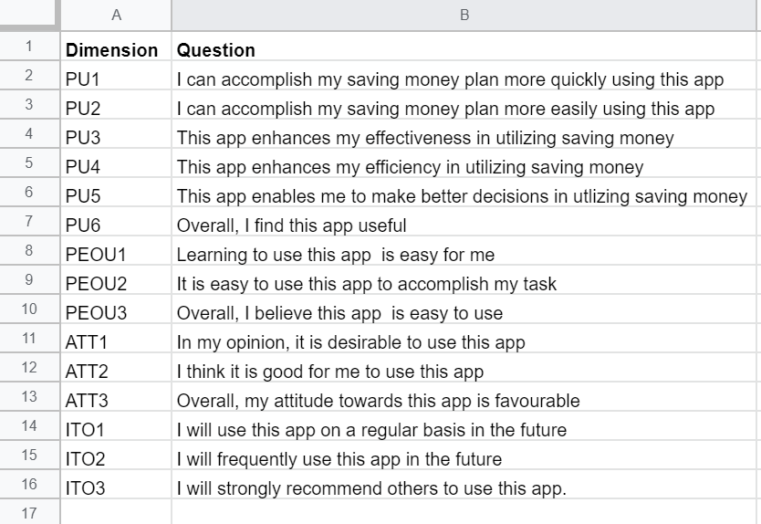

**Task2- Heuristic Evaluations**

**Our second task is Heuristic evaluations.**

We would like you to finish the Heuristic evaluations. In this session, you need to give your thoughts, understanding, and opinions of our project based on ``Jakob Nielsen's 10 general principles for interaction design". Your response will be recorded and generated in a doucment. These records will not be used for any other purpose. The principles are shown below.

1. Visibility of system status

## Match between system and the real world

## User control and freedom

## Consistency and standards

## Error prevention

## Recognition rather than recall

## Flexibility and efficiency of use

## Aesthetic and minimalist design

## Help users recognize, diagnose, and recover from errors

## Help and documentation

Do you have any questions about the task you are about to complete? Now let’s do the next task.

**Task3- Pluralistic Walkthrough**

Our final task for high fidelity prototype is Pluralistic walkthrough

For the last part, you will need to finish 9 tasks through our prototype by yourselves. These tasks mainly revolve around your desired prototype structure and need to be evaluated and improved in conjunction with current high-fidelity prototypes.Your response will be recorded and generated in a doucment. These results will not be used for any other purpose. Feel free to ask any questions while doing the evaluation.

Here are the following tasks we would like you to complete today:

1. “Say that you are a new user to this application. How would you think about logging into the application, and what would you expect the next page to be?”
2. “You would like to check your monthly bill in this application, what kind of bill would you expect to see, do you think the bill function is useful for this application?”
3. “You would like to check your budget in this application, what kind of content would you expect to see in the budget page. What would you expect to happen when you click the save button? Do you think the bill function is useful for this application?”
4. “You would like to pay for a product, what kind of content would you expect to see. What would you expect to happen when you click on the QR code in the middle of the page? ”
5. “You would like to view some courses provided by this application, what would you expect to see on the screen after you reach the courses page. What would you expect to see in the Shopping cart page? What would you expect to happen after purchase courses in the Shopping cart page”
6. “You would like to see some coupons, what type of coupons would you expect to see. What would you expect to happen when you click on the coupons for specific categories? ”
7. “What would you expect to see after clicking the add bill button.What would you expect to happen after clicking the plus icon?”
8. “You want to find out what your friend or someone you followed posted on this app. How do you want to do that and what do you expect to see on that page ?”
9. “You want to change the theme color of this app, what changes do you expect to see after changing the theme color?”

Do you have any questions about the task you are about to complete? Thank you for doing this evaluation, have a nice day!

**Appendix 2.1 Technology Acceptance Model (TAM) Process**

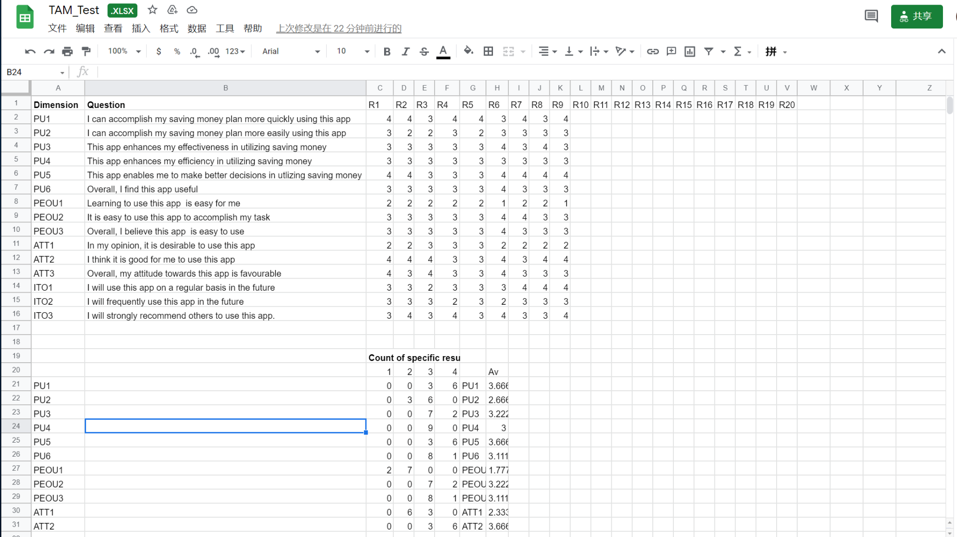

**Appendix 2.2 Heuristic Evaluations Process**

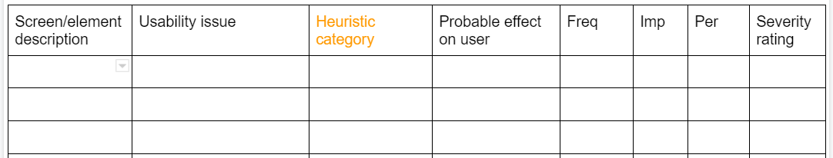

**Appendix 2.3 Pluralistic Walkthrough Process**

1. “Say that you are a new user to this application. How would you think about logging into the application, and what would you expect the next page to be?”

* For example, I log in with a third-party account, and I expect to get a feedback, eg. WeChat login is successful, fb login is successful, so that the user can confirm that the operation is correct.
* And when the third-party account logs in, I hope to have a confirmation or cancellation page to prevent me from clicking wrong;
* If I use the mailbox to register, I hope to get email Verification after the registration is successful.

1. “You would like to check your monthly bill in this application, what kind of bill would you expect to see, do you think the bill function is useful for this application?”

* The lack of currency units (the conversion between different currency units can be increased) may mislead users.
* Users will think that this is the points within the app (because the purchase of courses can be purchased through points) rather than the actual amount of consumption;
* income data source is not clear.
* The bill category selected during billing is displayed in the bill, and it is hoped that after clicking the daily bill, the spending details of the day will appear.
* Useful.

1. “You would like to check your budget in this application, what kind of content would you expect to see in the budget page. What would you expect to happen when you click the save button? Do you think the bill function is useful for this application?”

* I don’t know what data can be edited.
* Expend’s white box misleads users into thinking that it can be edited.
* Can remove the white box; useful.
* After Save, the pop-up window "Saved".
* I hope there is a white box when I click change;
* The background is a bit complicated, I can’t read the words

1. “You would like to pay for a product, what kind of content would you expect to see. What would you expect to happen when you click on the QR code in the middle of the page? ”

* Verification by face id or touch id, the PIN code is easy to be peeked outside;
* and shows how much money has been spent instead of only showing the remaining amount;
* I hope that the payment method (faceid, touch id or pin) can be selected in the settings.

1. “You would like to view some courses provided by this application, what would you expect to see on the screen after you reach the courses page. What would you expect to see in the Shopping cart page? What would you expect to happen after purchase courses in the Shopping cart page”

* Course content and introduction, evaluation (score), etc.;
* total amount, add and remove buttons; tips for successful purchase, including consumption amount, remaining budget, etc.
* And provide the details of the course provider, you need to know whether the course content is reliable.
* After the purchase, you can choose to jump directly to the course details page and start learning.

1. “You would like to see some coupons, what type of coupons would you expect to see. What would you expect to happen when you click on the coupons for specific categories? ”

* Shopping, coupon that can be used for cash, or even coupon that can be used in the app as a budget-free gold medal (for example, allowing users to exceed the budget and then use a coupon);
* coupons under each category, but some icons allow People are confused, and some categories will overlap, which will increase the difficulty for users to find coupons.
* And can add instructions for use.
* Hope to see cash coupons.
* Can see different types of coupons (in text form, etc.) more intuitively.

1. “What would you expect to see after clicking the add bill button.What would you expect to happen after clicking the plus icon?”

* I expect users to click on the text add bill, because other functional pages in the navigation bar are jumped by clicking on the text.
* Both Add bill and pictures can be clicked.
* It can be added directly, and the adding column will be displayed below after clicking the icon.

1. “You want to find out what your friend or someone you followed posted on this app. How do you want to do that and what do you expect to see on that page ?”

* I can see their dynamics, such as whether they have exceeded their budget this month, and their ways to save money;
* I can interact with them, such as comments and likes. There are more useful recommendations.

1. “You want to change the theme color of this app, what changes do you expect to see after changing the theme color?”

* Make it convenient for users to use at night, such as dark mode
* Can customize the picture as the background, and change the color of the function bar according to the main color in the picture.

**Appendix 2.4 Scenario**

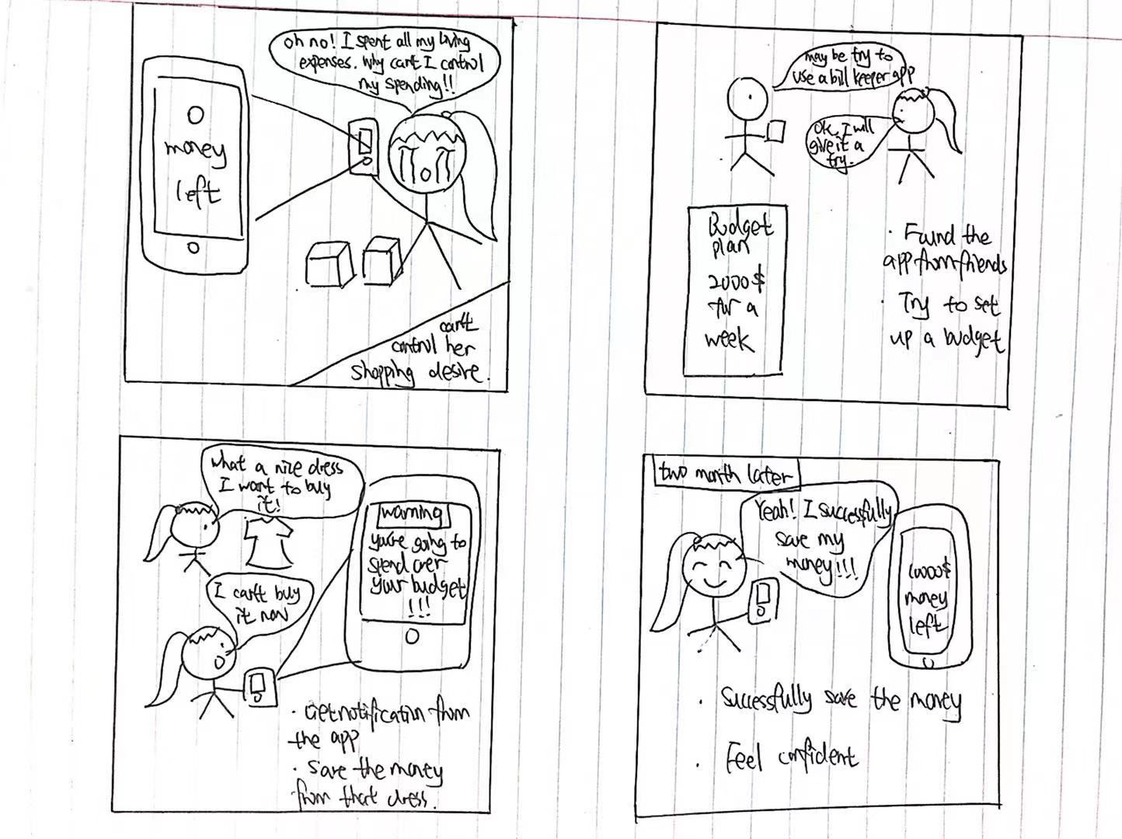

User Interaction scenario 1

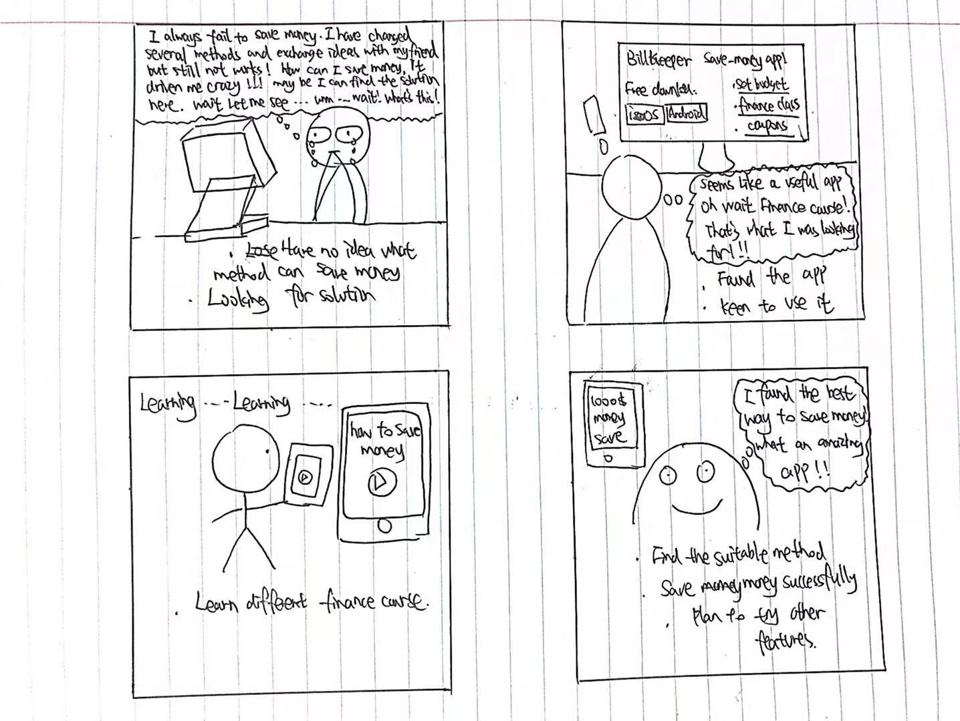

User Interaction Scenario2

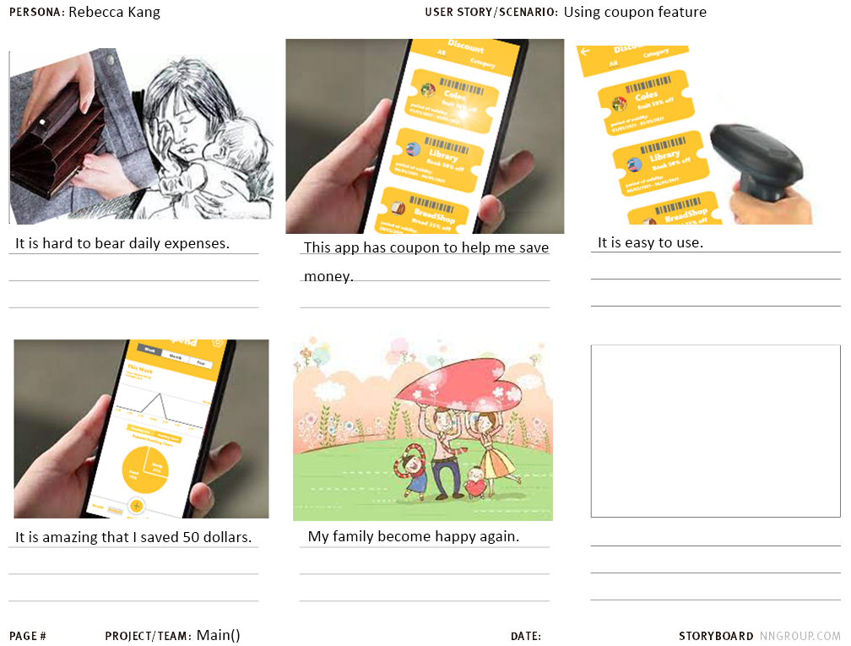

User Interaction Scenario3

**Appendix 3.0 Participant Information Sheets**

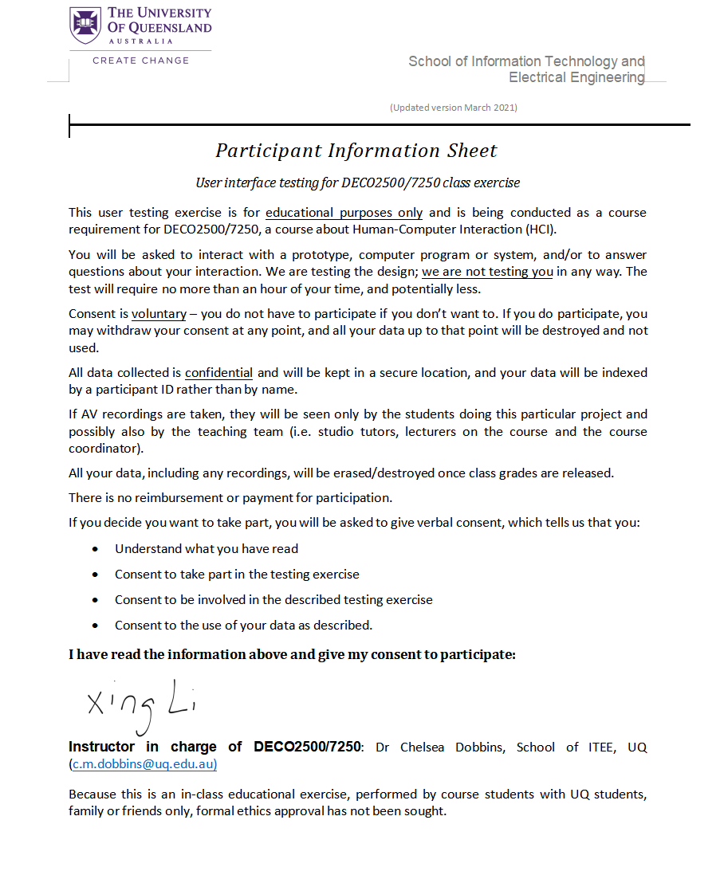

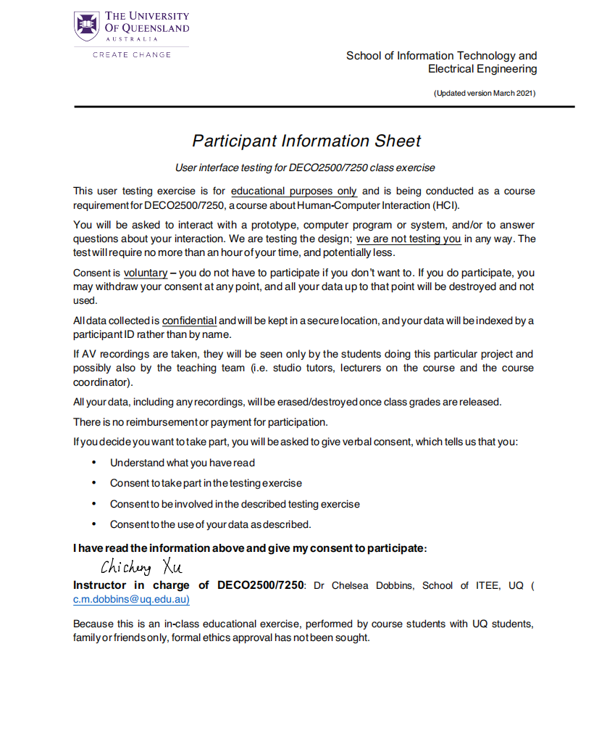



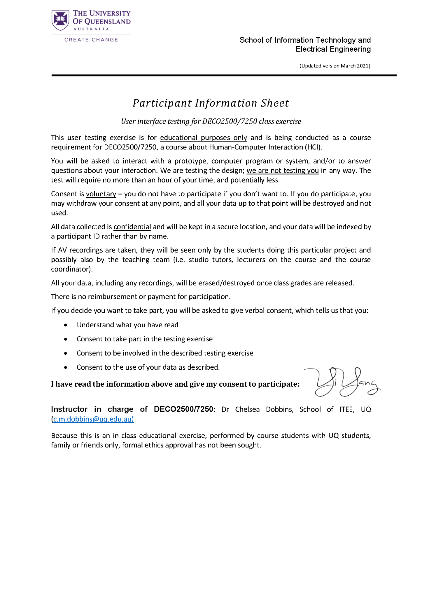

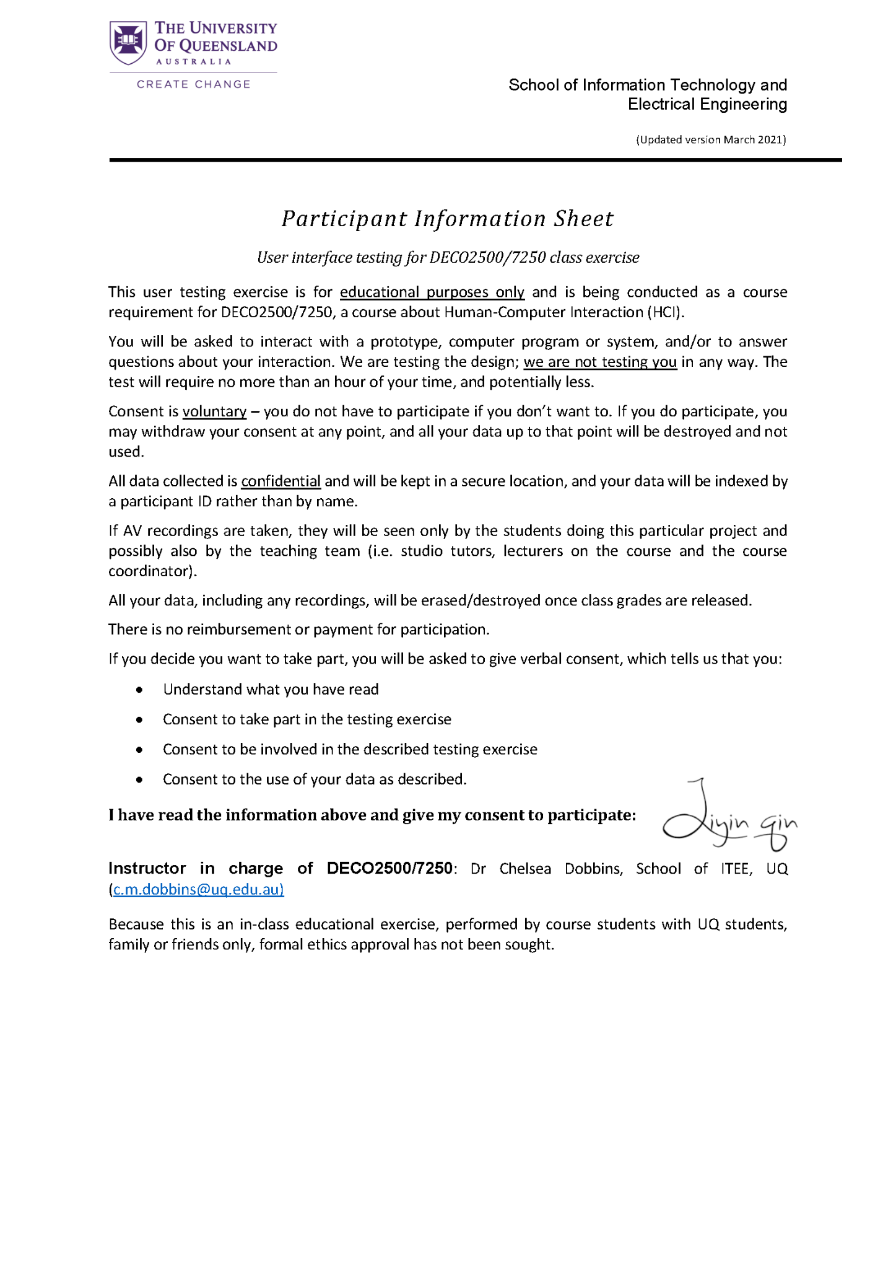

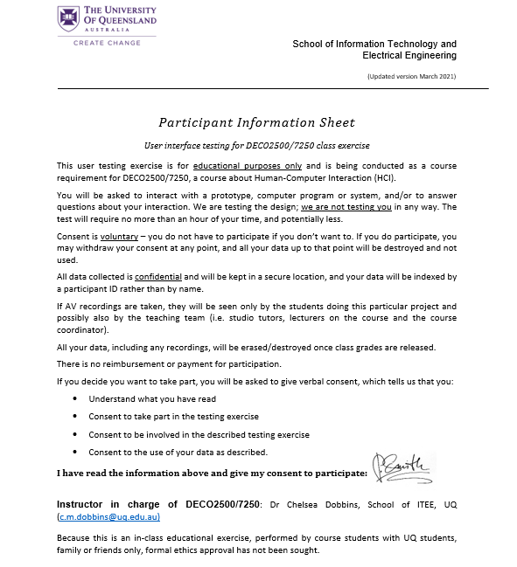

**Appendix 4.0 Meeting Logs**

**Meeting log_Week 7**

**Date:**

04/12/2021-04/18/2021

**Team Name:**

Main()

**Items Discussed/Worked On**

We discussed what the project topic should be. We shared our thoughts and decided to choose Limei Shen’s idea. Her idea was an app that helps people save money and learn budgets.

**Issues That Arose**

We are obsessed with two different topics.(solved)

**Actions Required**

Discussing the feasibility of each project topic.

Sharing each other’s topics and opinions.

Reviewing the power slide.

**Deliverables/Plan To Be Completed By The Next Week**

Evaluation

Formative feedback

**Other Comments**

1. Tuesday 10-12 am zoom meeting (13/4)
2. Friday 2:30-3:30pm zoom meeting

**Signed and Accepted**

Limei SHEN

Yingxin LIU

Keyu Bai

Zhongyang Zheng

**Meeting log_Week 8**

**Date:**

04/19/2021 - 04/25/2021

**Team Name:**

Main()

**Items Discussed/Worked On**

Analyse the survey result

Medium Fidelity Prototype

Evaluation (think aloud, sus)

**Issues That Arose**

Unsure about the detail of the UX goal

**Actions Required**

Review the survey result.

Finish UX goals

Improve the low fidelity Prototype.

**Deliverables/Plan To Be Completed By The Next Week**

Undertake Evaluation

**Other Comments**

1. Monday 20:30 -22 pm zoom meeting
2. Friday 20:30 - 22pm zoom meeting

**Signed and Accepted**

Limei SHEN

Yingxin LIU

Keyu Bai

Zhongyang Zheng

**Meeting log_Week 9**

**Date:**

04/26/2021 - 05/02/2021

**Team Name:**

Main()

**Items Discussed/Worked On**

Based on the response of the tutor and the result of the survey, decide the detail of the ux goal

Medium Fidelity Prototype

**Issues That Arose**

Determine how many UX goals we should have?

**Actions Required**

Review the survey result.

Finish UX goals

Improve the low fidelity Prototype.

**Deliverables/Plan To Be Completed By The Next Week**

Finish UX goal and the medium fidelity prototype

**Other Comments**

1. Monday 11:30 - 12:30pm zoom meeting

**Signed and Accepted**

Limei SHEN

Yingxin LIU

Keyu Bai

Zhongyang Zheng

**Meeting log_Week 10**

**Date:**

05/03/2021-05/09/2021

**Team Name:**

Main()

**Items Discussed/Worked On**

Survey

Adjusting UI

UX goal

**Issues That Arose**

Lack of contents

Hard to design icons.

**Actions Required**

Find useful icons.

Adding contents

Doing SUS and design walkthrough survey

**Deliverables/Plan To Be Completed By The Next Week**

Completing survey

Analyzing data

Finishing Medium Fidelity Prototype

Starting Medium Fidelity Prototype Evaluation

**Other Comments**

1. Saturday 4-6 pm zoom meeting

**Signed and Accepted**

Limei SHEN

Yingxin LIU

Keyu Bai

Zhongyang Zheng

**Meeting log_Week 11**

**Date:**

05/10/2021-05/16/2021

**Team Name:**

Main()

**Items Discussed/Worked On**

We discussed and integrated the result of the user test. 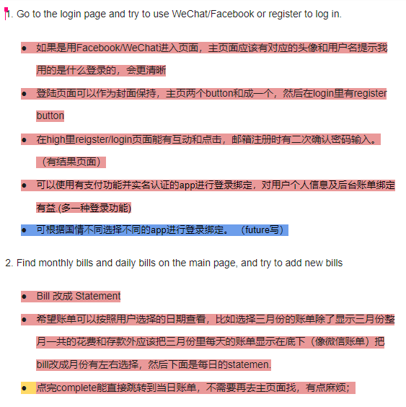

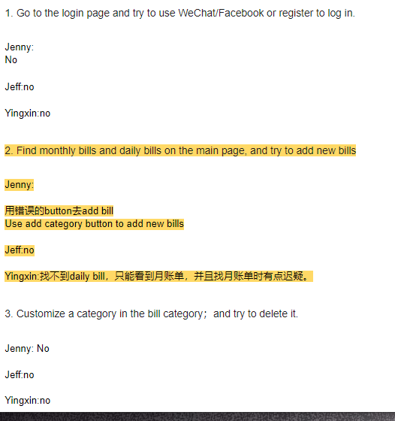

Below is a screenshot of the meeting.

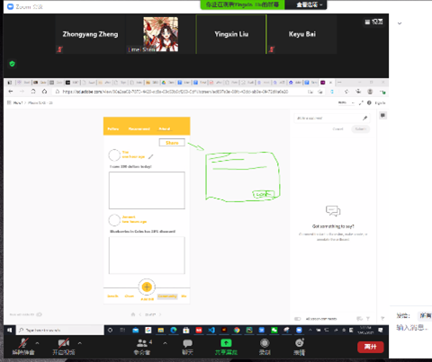

**Issues That Arose**

We found that there were too many results and it was impossible to put everything into the report.(solved)

**Actions Required**

Choosing important comments and putting them into the main text of the report. Choosing less important comments and putting them into the appendix of the report.

**Deliverables/Plan To Be Completed By The Next Week**

Evaluation.

High fidelity prototype.

**Other Comments**

1. Thursday 2:00-4:00pm

**Signed and Accepted**

Limei SHEN

Yingxin LIU

Keyu Bai

Zhongyang Zheng

**Meeting log_Week 12**

**Date:**

05/17/2021-05/23/2021

**Team Name:**

Main()

**Items Discussed/Worked On**

We checked whether each member finished the work. Zhongyang Zheng and Yingxin Liu finished the Medium Fidelity Prototype. Limei Shen and Yingxin Liu finished Requirements. Keyu Bai finished Evaluation. In conclusion, everyone finished the arranged job. Zhongyang Zheng took notes and wrote a meeting log.

Making a High Fidelity Prototype.

Doing High Fidelity Prototype Evaluation.

**Issues That Arose**

The typographic design was not perfect.

This is the original design.

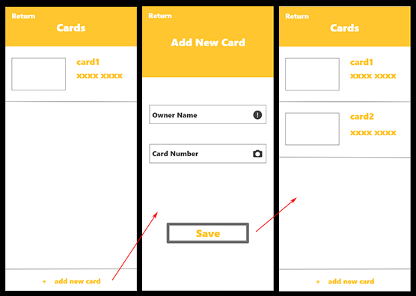

This is the latest version.

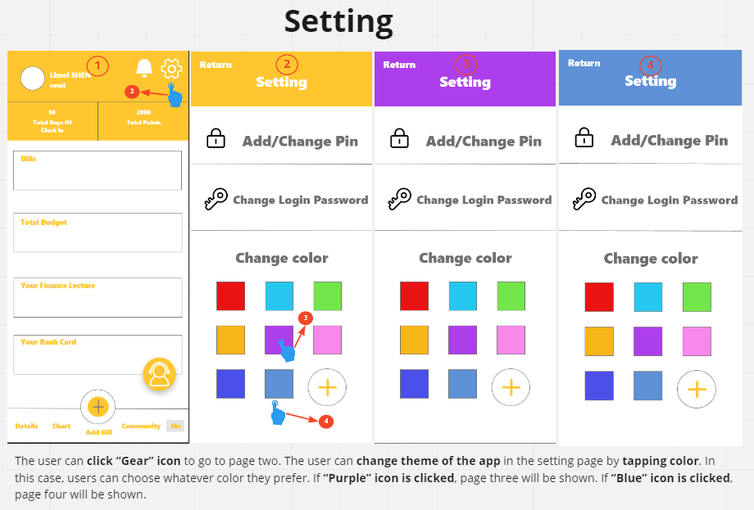

Evaluation is too cumbersome. (Not finished)

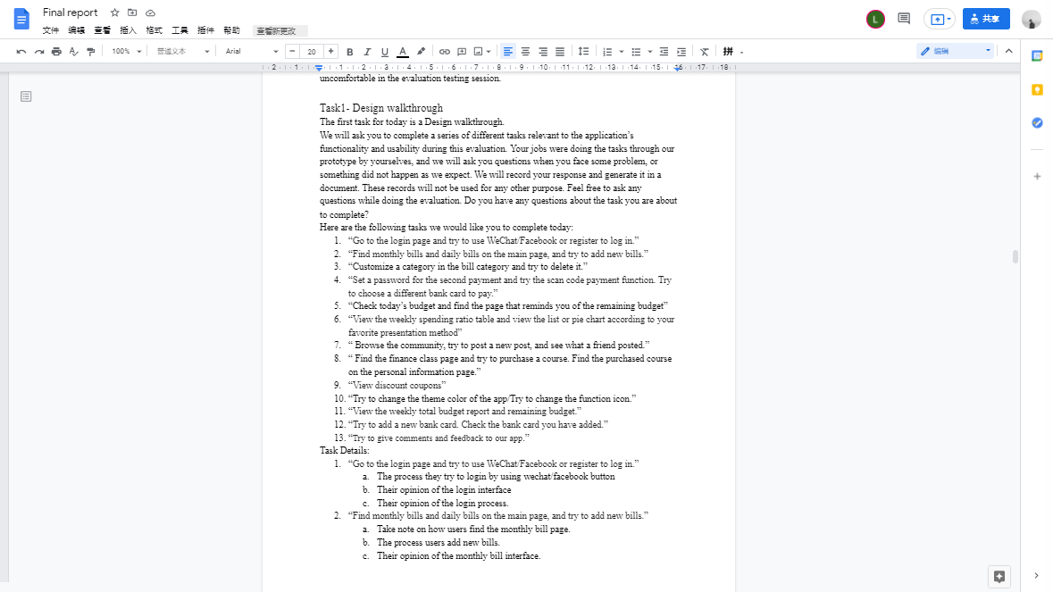

**Actions Required**

Adjusting typographic design. Using the finger icon instead of the red line.

Integration of evaluation. Putting table into appendix. Writing only the conclusion.

**Deliverables/Plan To Be Completed By The Next Week**

Zhongyang Zheng writes meeting log, High Fidelity Prototype and adjusts typographic design of Medium Fidelity Prototype.

Limei Shen makes High Fidelity Prototypes and writes revised requirements.

Yingxin Liu makes High Fidelity Prototype evaluation and adjusts typographic design of Medium Fidelity Prototype.

Keyu Bai improves Medium Fidelity Prototype Evaluation.

Everyone needs to do user testing and write reflection.

**Other Comments**

1. Meeting Monday 2:00-4:00pm

**Signed and Accepted**

Limei SHEN

Yingxin LIU

Keyu Bai

Zhongyang Zheng

**Meeting log_Week 13**

**Date:**

05/24/2021-05/28/2021

**Team Name:**

Main()

**Items Discussed/Worked On**

We checked whether each member finished the work. Zhongyang Zheng wrote a meeting log and a High Fidelity Prototype.

Limei Shen made a High Fidelity Prototype and wrote revised requirements. Limei Shen and Zhongyang Zheng designed the scenario of persona.

Yingxin Liu wrote a High Fidelity Prototype and made a High Fidelity Prototype evaluation.

Keyu Bai wrote a Medium Fidelity Prototype Evaluation. Yingxin Liu and Keyu Bai integrated the whole report and checked professionalism.

Everyone did user testing and wrote reflections.

**Issues That Arose**

During the user test, we found that the table of Heuristic Evaluation was not correct. (solved)

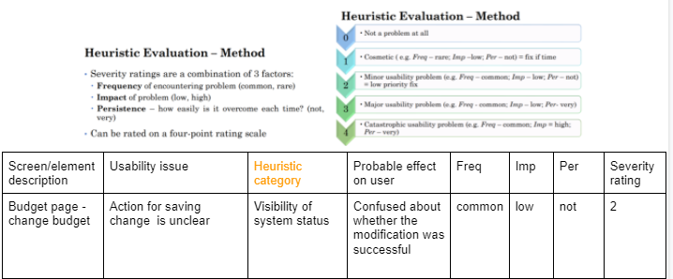

No annotation in the High Fidelity Prototype.(solved)

No scenario.(solved)

**Actions Required**

Finding information about the table and asking the user to do another type of test first.

Adding annotation in the High Fidelity Prototype.

Adding scenario.

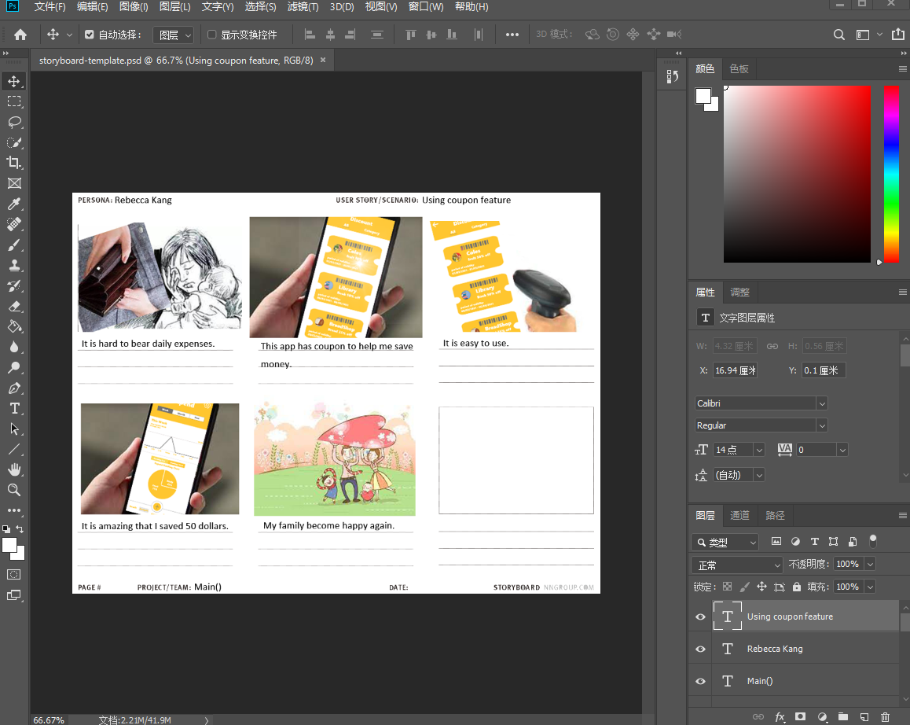

(Designed by Zhongyang Zheng)

**Deliverables/Plan To Be Completed By The Next Week**

None

**Other Comments**

1. Meeting Monday 2:00-4:00pm
2. Meeting Tuesday 4:00-6:00pm
3. Meeting Wednesday 4:00-6:00pm

**Signed and Accepted**

Limei SHEN

Yingxin LIU

Keyu Bai

Zhongyang Zheng

**Appendix 4.0 Team charter**

Team charter

**Date: 29/03/2021**

**Team Name: main()**

**Team Members**

**Name: Keyu Bai**

**Email** *(Use your UQ email)*: keyu.bai@uq.net.au

**Name: Limei SHEN**

**Email** *(Use your UQ email)*: limei.shen@uq.edu.au

**Name:Yingxin LIU**

**Email** *(Use your UQ email)*:yingxin.liu@uq.edu.au

**Name: Zhongyang Zheng**

**Email** *(Use your UQ email)*: zhongyang.zheng@uqconnect.edu.au

**Online tools**

***Messaging or Discussions***

Slack: DECO2500/7250-2021 -> #Studio U01

**Other messaging tools**

Google Groups

Slack Group

WeChat Group

***Online Meetings***

Zoom

WeChat

***Creating documents***

Google Drive – Doc, Sheets, etc.

<https://drive.google.com/file/d/1-ciCZOVdge_n9dh3XEuAj9c7N9lWGR3a/view?usp=sharing>

**Responding to messages and emails**

How often should we check messages and emails?

Messages: Once a day

Emails: Once a day

When assessments are due should we check more often? Yes

Communication response time (see 6): As soon as possible.

**Meetings/time**

Whole of team meeting day and time (see 1b): Every studio, twice a week beside the studio.

Additional work sessions each week (see 1c): 21 hours per week

Time to fix an issue (see 15a): As soon as possible

**Privacy**

Do we need to record online meetings?

Yes No

***Problems or Disagreements***

What should we do if we have a problem with another team member’s behaviour or work?

Communicate with the team member first, if it is not working ask help from tutors.

**Team Roles**

Leader (to keep the group motivated or on task): every team member (rotate)

Note or minute taker: Zhongyang Zheng

Other team role(s):

Assignment reminder: Limei SHEN

Will we rotate roles?

Yes No

If so, how often will we rotate?

Rotate once a week

Other comments:

None

**Signed and Accepted**

Limei SHEN

Keyu BAI

Zhongyang ZHENG

Yingxin LIU

**Our Commitment**

1. As a team, we commit to:

a. Use our best endeavours and efforts throughout the project.

b. Attend all course studio sessions, the whole of team meeting as specified above, and any additional meetings agreed on by the team.

c. Dedicate necessary time and effort as is required by the team including the additional hours per week specified above.

d. Contribute to the project equally.

Work consistently and complete all required tasks on time and at a quality as agreed by the team.

2. We will work together by:

a. Supporting each other;

b. Being respectful and inclusive;

c. Sharing resources;

d. Listening to each other;

e. Providing feedback to each other;

f. Always being constructive and polite; and

g. Maintaining a high level of communication.

**How we will communicate**

3. We will use the team communication channel for all our team communication.

4. Where necessary, we will also communicate via email and/or other online tools using the details for each team member provided at the start of this charter.

5. Each of us commits to checking the team communication channel at least daily, except on weekends and public holidays.

6. We will respond to messages on the team communication channel within the communication response time specified above.

**How we will make decisions**

7. Decisions about the project will be made by consensus (with all team member’s agreement).

8. We will work towards reaching agreement by working through pros and cons and assessing what is best for the project.

9. Where we cannot achieve consensus, decisions will be made by majority vote.

10. Where there is a deadlock, the decision will be made by the team leader.

11. Once a decision has been made, we all agree to accept and support that decision.

**Managing work**

12. We will allocate work equally.

13. When allocating work, we will clearly define:

a. Who is expected to complete the work;

b. The task that is expected to be completed;

c. When the work is to be completed; and,

d. The expected standard of the work.

14. If a team member is not able to complete the work allocated to them, they must advise the team of this as soon as possible.

15. If a team member has not completed the work allocated to them within the set timeframe or not to the specified standard:

1. The issue must be raised with that team member directly and agree what that team member must do to complete or fix the work. The team member must complete or fix the work within the time to fix an issue as specified above.

b. If the team member fails to complete or fix the issue within this time, the team leader must send an email to that team member asking them to complete or fix the work within a further 24 hours. That email should be copied as a ‘cc’ to the tutor.

c. If the work is not completed within that time further extended time, the team leader shall email their tutor advising them of this and ensure that a copy of this email is sent to the team member.

**Reference(APA 7th)**

Affairs, A. S. for P. (2013, September 6). *System Usability Scale (SUS)*. Usability.gov. https://www.usability.gov/how-to-and-tools/methods/system-usability-scale.html.

Allen, R. (2020, November 17). *The Technology Acceptance Model*. Smart Insights. <https://www.smartinsights.com/manage-digital-transformation/digital-transformation-strategy/digital-marketing-models-technology-acceptance-model/>

Aree, B. M. (n.d.). Medium Fidelity Prototyping. <http://www.anu.brighid.idc.ul.ie/CS6022-2020/Assignments/Brian%20Mac%20Aree%20v1-8.pdf>

Bias, R. G. (n.d.). *Pluralistic Usability Walkthrough | Usability Body of Knowledge*. Usability Body of Knowledge. Retrieved May 27, 2021, from https://www.usabilitybok.org/pluralistic-walkthrough

Goel, T. (2009, May 20). *An Effective Design Walkthrough: A Step Towards Delivering the Best Design*. Project Smart. https://www.projectsmart.co.uk/an-effective-design-walkthrough-a-step-towards-delivering-the-best-design.php.

Nielsen, J. (1994, April 24). *10 Usability Heuristics for User Interface Design*. Nielsen Norman Group. <https://www.nngroup.com/articles/ten-usability-heuristics/>

Nielsen , J. (2012, January 15). *Thinking Aloud: The #1 Usability Tool*. Nielsen Norman Group. https://www.nngroup.com/articles/thinking-aloud-the-1-usability-tool/.

Robert FarringtonRobert Farrington is America’s Millennial Money Expert® and America’s Student Loan Debt Expert™. (2021, April 5). *The 50 Best Ways To Save Money In College*. The College Investor. https://thecollegeinvestor.com/22453/save-money-in-college/.

[Robert Farrington](https://thecollegeinvestor.com/author/robert/). (2021, April, 4).*Ten Common Financial Challenges - Oklahoma* Central Credit Union. (n.d.). <https://www.oklahomacentral.creditunion/Ten-Common-Financial-Challenges>.

Wikipedia contributors. (2021, May 4). *Heuristic evaluation*. Wikipedia. https://en.wikipedia.org/wiki/Heuristic_evaluation